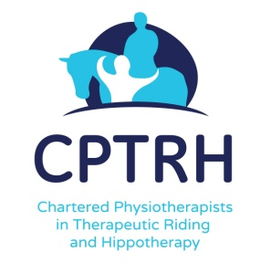

PHYSIOTHERAPISTS WORKING IN RDA
A study day for Physiotherapists who are, or want to be, involved with the RDA

This course is also open to Occupational Therapists and Speech & Language Therapists

Subjects to be covered include
- understanding the structure and function of the RDA
- an exploration of the activities offered
- understanding where a physiotherapist fits in to the organisation
- how a physio can assist riders and support the coach
- financial and insurance considerations
The day will be led by Elizabeth Beckerlegge MCSP of Riding for Rehab and Chair of CPTRH. Elizabeth has been involved with the RDA for many years.

Date: Sunday 17th March 2019
Venue: Middleton Park Equestrian Centre, Leeds LS11 5TZ
Time: 9.30 – 4.30
Cost: £25.00p (£20 to CPTRH members) includes a light lunch
Applications to: Denise Robertson, Head of Therapy email: drobertson@rda.org.uk

Similar days will be held in other parts of the country later in 2019 according to demand. Expressions of interest to Elspeth O’Donnell, CPTRH secretary elspethodonnell@gmail.com

