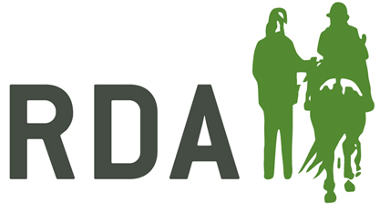
ACCIDENT/INCIDENT WITNESS FORM

- ABOUT YOU:
Full Name:
Address:

Post Code:
Email Address:
Your role in RDA:

- ABOUT THE ACCIDENT/INCIDENT:
Date: / /
Time:
Where did the accident/incident happen?

Was there Injury Damage only Near miss/unsafe

- DESCRIBE WHAT HAPPENED, PROVIDING AS MANY DETAILS AS POSSIBLE (use a separate sheet if necessary)

SIGNATURE: DATE:

