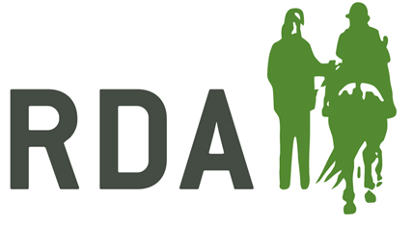
AGMS and Trustee Meetings During Coronavirus

Advice from OSCR (Scotland)
AGMs
The COVID-19 pandemic is going to have an impact on your ability to hold your AGM. This might make it difficult for you to finalise your annual report and accounts.
Wherever possible, we would ask you to try to get these to us on time. All you need to do is log on to OSCR Online as usual and scan us your report and accounts. However, we understand that it might be difficult for some and we will take an understanding and proportionate approach to this and no charity in this situation will be penalised for being late. See the Reporting to OSCR section of the guidance for more in accounts.
It may be that by postponing your AGM, you are not fulfilling what it says in your governing document. However, we would be understanding and proportionate about that.
TRUSTEE MEETINGS
Meeting face-to-face is not going to be possible at the moment so holding meetings virtually will be a good option. Some charities have specific provisions in their governing documents to allow meetings to take place over the phone or using digital solutions. However, in the current situation, we are happy that charities hold their meetings in this way even if the governing document doesn’t say anything about this. This will allow charity trustees to have important discussions and to take decisions at this difficult time. Where you decide to take this virtual route, you should record that they have done this, demonstrating good governance of your charity.

Advice from Charity Commission (England and Wales)
AGMS
Coronavirus is having a major impact on charity events and the government’s health advice may lead to some charities having no choice but to decide to cancel or postpone their AGMs and other critical meetings.
If as trustees, you decide it is necessary to do so, you should record this decision to demonstrate good governance of your charity. This is particularly important if it is not possible to hold your AGM which may make it difficult for you to finalise your annual reports and accounts.
Wherever possible, we would ask you to try to get your annual reports to us on time. However, where the situation impacts on the completion of annual returns and accounts, charities with an imminent filing date can email us.
Please include your charity name and charity registration number when you email us: filingextension@charitycommission.gov.uk

TRUSTEE MEETINGS
In the current situation, it is becoming increasingly difficult to hold face-to-face meetings. Some charities have clauses in their governing documents that allow them to meet virtually or to use telephone facilities, so we advise trustees to check their governing document and see if they can make amendments themselves to facilitate changes as to how or when meetings are held.
Where there is no such clause in your governing document and you decide to hold meetings over the phone or using digital solutions, we will understand but you should record this decision and that you have done this to demonstrate good governance of your charity.

Advice from Charity Commission NI (Northern Ireland)
AGMs
Charity trustees who cannot hold an annual general meeting (AGM) in compliance with their Articles of Association must ensure that the decision is recorded by the charity.
Any record of such decisions should record that the decision was taken in response to the current health advice, and that plans to hold the AGM will be implemented as soon as reasonably possible after government advice on holding meetings changes.
The Commission will be pragmatic and reasonable and will not take any regulatory action where meetings are postponed as a result of these circumstances.
TRUSTEE MEEETINGS
In keeping with the government’s current advice it will be very difficult for charities to hold face-to-face meetings. Some charities have clauses in their governing documents that allow them to meet virtually or to use telephone facilities.
Where your charity does not have the power and you decide to hold meetings over the phone or using digital solutions, you should record this decision and note that you have done this to demonstrate good governance of your charity and in keeping with the government’s advice. The Commission will accept decisions recorded in this way.

