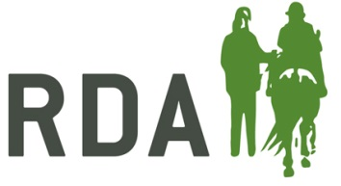
APPLICATION FORM FOR BRONZE / SILVER / GOLD PROFICIENCY TEST EXAMINATION
Exams are arranged by RDA National Office.
Bronze: £10.00 per candidate or £7.50 for a section
Silver / Gold: £30.00 per candidate or £20.00 for a section of the test.

Please send this completed application form, with a non-returnable fee to the Qualifications Co-ordinator at RDA National Office, Norfolk House, 1A Tournament Court, Edgehill Drive, Warwick, CV34 6LG
An Examiner will be appointed by the Coaching Team and Certificates etc. will be forwarded to the examiner/ organiser.
The Bronze Test Can be taken in the Home Centre.
Please circle which test you are applying for: BRONZE SILVER GOLD

Group
Region
Name & Address of Group Organiser | Miss /Mrs/Mr
Telephone Number

Name of accompanying Instructor | Miss/Mrs/Mr
(Gold / Silver Candidates only)  Rider Assessed by | Miss/Mrs/Mr
Name of Rider | Miss/Mrs/Mr
Height & Weight
Brief Description of disability | 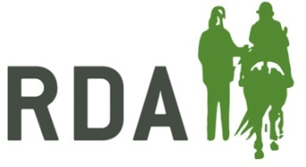
Indicate Sections being attempted | Both / Riding / Horse Care
(Gold / Silver candidates only)  Indicate Jumping or Riding Test | Jumping / Riding Club Test
Have you attempted this test before? | Yes / No
Have you already passed a section? | Riding / Horse Care
Suggested Date(s)

Maximum distance riders can travel

Where the exam is to be taken

October 2016

