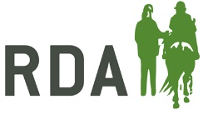
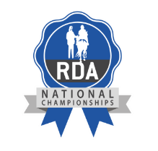
Competition Code of Conduct
for Competitors, their Carers and Supporters

RDA UK is fully committed to safeguarding and promoting the wellbeing of everyone involved and wants to ensure a positive and enjoyable experience for all. When attending competitions, everyone is expected to abide by the following code of conduct:-

- All riders and drivers and/or their carers must take responsibility for ensuring they are up to date with the rules; understand and adhere to them.

- All riders, drivers, carers and supporters should recognise the valuable contribution made by all officials, who are usually volunteers. They give their time and resources to enable the event to happen.

- All riders, drivers, carers and supporters must respect officials and their decisions.

- All officials must treat everyone equally and with dignity.

- All those attending the event should treat others with the same level of respect that they would expect to be shown to themselves.

- Everyone must respect the rights, dignity and worth of all; regardless of age, gender, ability, race, cultural background, religious beliefs or sexual identity.

- Everyone must ensure that inappropriate language or behaviour is challenged.

If you have a concern:-

If anyone has a concern leading up to the event, please either refer to the RDA Group Safeguarding Officer or contact RDA UK’s Lead Safeguarding Officer on 01926 492973 / 01926 405969

