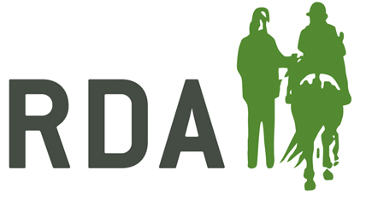
PARTICIPANT CONSENT FORM

GROUP NAME:

PARTICIPANT NAME:

The measures necessary to minimise the risk of the spread of the infection need to be observed by everyone.
In preparation of getting started after lockdown, the Group has:-
- Ensured the venue has been cleaned, with all hard surfaces and equipment sanitised.
- Displayed signs on site to remind everyone of the need for social distancing and thorough hygiene regimes.
- Taken supplies of sufficient soap/sanitising products and disposable hand towels to allow regular hand washing.
By returning to the Group and signing this form you are confirming that you do not need to self-isolate and acknowledge the RDA Group has taken all reasonable steps to reduce the risks of COVID-19 and agree to the following protocols:-
- You will ensure before each visit to the group, that you are not displaying any COVID-19 symptoms requiring self-isolation i.e. high temperature, a new persistent cough or loss of smell or taste; or living with anyone who is displaying any of these symptoms.
- If symptoms are evident, for you or anyone in the household, you will contact the Group to let them know and you will stay at home in line with government guidelines.
- You will thoroughly wash or sanitise your hands on arrival.
- You will endeavour to follow standard social distancing at all times possible i.e. remain at 2m/6ft distance from others (other than your parents/carers, when applicable).
- If you fall ill, or display any of the symptoms during your visit, you will advise somebody then return home immediately, avoiding touching anything where possible and follow advice on self-isolation.
Signature | Participant/Parent/Legal Guardian (delete as appropriate) | Date:
If consent has been given by the participant’s parent or legal guardian:-
Name |  | Relationship to Participant

