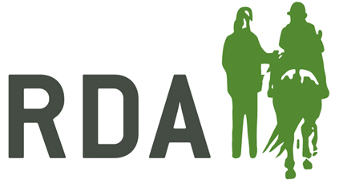
STAFF/SELF-EMPLOYED CONSENT FORM

GROUP NAME:

STAFF/SELF-EMPLOYED NAME:

The trustees have a duty of care to all staff and self-employed, ensuring that we keep you as safe as possible. We will do this by carrying out risk assessments, putting in place a safe system of work, and providing appropriate equipment and training.

In turn, you must take reasonable care of your own and other people’s health and safety. This means:
- following health and safety directions;
- following the training you have received when using any work items given to you;
- telling a manager or a trustee if you think the work or inadequate precautions are putting anyone’s health and safety at serious risk

In addition, by signing this form you are confirming that you do not need to self-isolate, acknowledge the trustees have taken all reasonable steps to reduce the risks of COVID-19 and agree to the following protocols :-
- You will ensure before each working day, that you are not displaying any COVID symptoms requiring self-isolation i.e. high temperature, a new persistent cough or loss of taste or smell, or living with anyone who is displaying either of these symptoms.
- If symptoms are evident, for you or anyone in the household, you will contact your line manager to let them know and you will stay at home, in line with government guidelines.
- You will thoroughly wash or sanitise your hands on arrival and regularly during your working hours, including before and after sessions.
- You will follow standard social distancing at all times where possible i.e. remain at 2m/6ft distance from others.
- If you fall ill, or display any of the symptoms whilst at work, you will advise somebody then return home immediately, avoiding touching anything where possible and follow advice on self-isolation.
- You will follow any other direction as may be issued in the future, to meet ongoing changes in government guidance.
If you do not feel able to sign up to these arrangements, please discuss with your line-manager as soon as possible.

Signature |  | Date:

