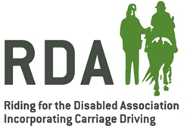
2022 Creative writing
Competition

The RDA Creative Writing Competition is now in its sixth year and as in previous years, we are offering three classes of poem, letter or short story and the theme for each class is simply ‘RDA.’

Your entry could be a story about an exciting experience you’ve had whilst at your RDA Group, or a poem about your favourite horse or pony.

The focus should be on your thoughts, imagination and the content – we don’t mind at all how you present your work. We just want you to be able express yourself in a way that is accessible to you.

Who can enter?
The RDA Creative Writing Competition is open to all RDA participants (riders, carriage drivers and vaulters), of all ages and abilities. We cannot accept entries from volunteers, unfortunately, unless they are also current RDA participants. Classes are open to individual entrants only. You may enter more than one class if you wish, but only one entry per participant, per class will be accepted.

How can pieces of writing be entered?
Entries can be submitted in any format (e.g. computer-printed, pencil, pen or typewriter copy). Braille entries can be submitted but please also supply a printed transcription. Printed or drawn Makaton symbols can be used. Entries in languages other than English are encouraged, too, but please provide an English translation to assist the judges. The competition is also a great opportunity to involve families, schools/ colleges or care centres too, as participants are welcome to create their entries at any time; in RDA sessions, in the classroom or at home.

How much will it cost to enter?
Entry is completely FREE! Simply send all entries with a fully-completed entry form (one form per entry) by Friday 25th February 2022. There will be no regional rounds of judging.

Please ensure that you keep your own copies of each entry safely, as we will be unable to return any work sent in to National Office. RDA National Office cannot be held responsible for any entries not received in time, lost, or damaged. All entries are sent entirely at the entrants’ own risk. Late entries cannot be accepted.

How and when will entries be judged?
Entries may or may not be accompanied with illustrations or decoration, however they will purely be judged on their written content by the judges.

Each entry will be considered on its own merit; the judge will be looking for specific relevance and reference to RDA, along with charm, imagination and appeal - not just simply an equestrian theme.

The closing date for receipt of entries at National Office will be Friday 25th February 2022 and the winners will be announced as soon as possible afterwards, in March 2022.

Class 1: A poem about RDA
Your poem doesn’t necessarily have to rhyme, but must have an RDA theme. Maximum 350 words. Open to all ages/ abilities - all entries will receive a rosette and congratulations letter!
First Prize: £20 Amazon voucher and special winner’s rosette

Class 2: A letter about RDA
Perhaps to someone special at RDA telling them about an achievement that you or someone else has had? Or maybe a letter thanking your favourite volunteer…or horse? Maximum 500 words. Open to all ages/ abilities – all entries will receive a rosette and congratulations letter!
First Prize: £20 Amazon voucher and special winner’s rosette

Class 3: A short story about RDA
It could be fact or fiction, but aim to inspire, entertain and amaze! You can be as imaginative or creative as you like, but make sure you don’t go over the limit of 500 words. Open to all ages/ abilities - all entries will receive a rosette and congratulations letter!
First Prize: £20 Amazon voucher and special winner’s rosette

The Creative Writing Competition 2022 is kindly supported by the players of People’s Postcode Lottery.
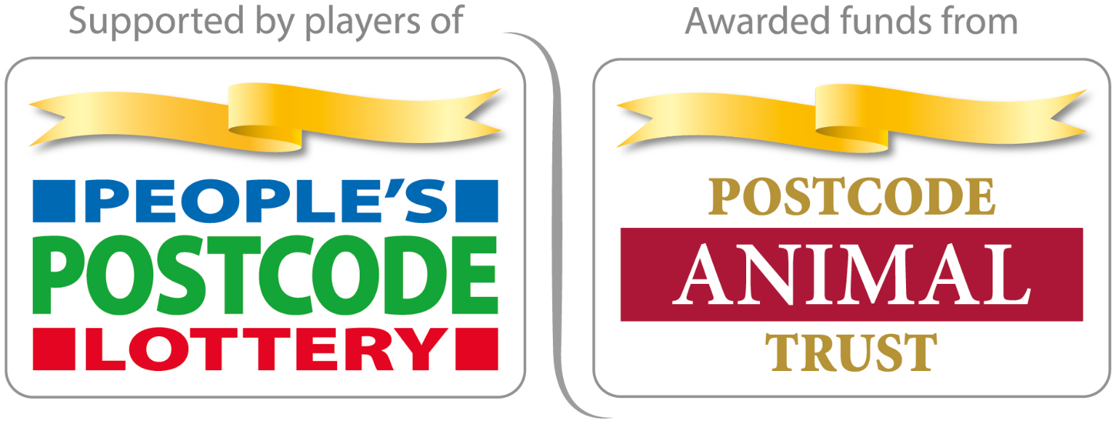

Creative Writing Competition 2022
Entry Form
Please complete clearly in BLOCK CAPITALS, or tick the appropriate box.
Completed forms, along with competition entries, will need to be sent to
Alex Walker at RDA National Office by Friday 25th February 2022

entry is completely free of charge

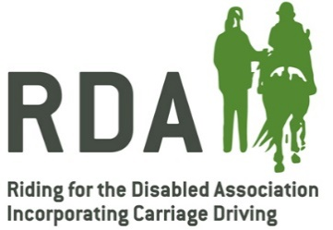

RDA Group |  | RDA Region

Correspondent Details
 |  | Title | Forename |  |  | Surname
Name
Address
Postcode |  |  |  | Email
Telephone |  |  |  | Mobile

Entry Title
Writer’s Name | Forename/s | Surname
✔
Category Details (please tick one only)
CLASS 1 | An RDA Poem – maximum 350 words, must have an RDA theme
CLASS 2 | A Letter – maximum 500 words, must have an RDA theme
CLASS 3 | A Short RDA Story - maximum 500 words, must have an RDA theme

We would like to use any entries received for promotion and publicity for the next 12 months on our website, in our publications and on social media which will be in the public domain. This can include the writer’s name, the writer’s group name and the contents of your entry.
✔
If you, or your parent, guardian or carer (if under 18 or relevant) are happy for us to do this, please tick this box clearly.

Instructions
Please send all entries (only one entry per participant, per class please) with a fully-completed entry form for each entry to Alex Walker at RDA National Office, Lowlands Equestrian Centre, Old Warwick Road, Shrewley, Warwickshire CV35 7AX (or email the completed entry form and the competition entry itself to awalker@rda.org.uk) by the closing date of FRIDAY 25TH FEBRUARY 2022. There will be no regional judging.

Please ensure that you keep your own copies of each entry safely, as we will be unable to return any entries sent in to National Office. RDA National Office cannot be held responsible for any entries not received in time, lost, or damaged. All entries are sent entirely at the entrants’ own risk. Late entries cannot be accepted.

DATA PROTECTION/ PRIVACY
In order to run this competition, we have to process the personal data (correspondent name, contact details, writer’s name) you provide to us in this application form and in your entry (any personal data included as part of the entry). We have a legitimate interest in doing so. If you do not provide this personal data we cannot contact you about your entry or identify you if you have won a prize. Any personal data you have provided will only be used in correspondence directly related to this competition and will be retained for a maximum of 12 months for promotion and publicity purposes if you have given us permission to do so by opting in on the application form. After this 12-month period this information will be deleted. We will not share your personal data with anyone outside RDA including any external judges of this competition.

