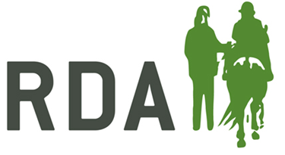

Completing an Online Disclosure Check as an admin

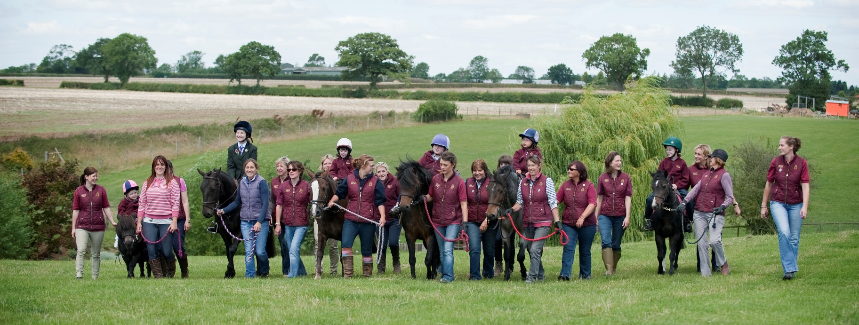
Step 1
Use the ID validation sheet, dated December 2017, to check your applicants ID. They must provide you with three forms of ID with one document from group 1 and two further documents from either group 1, 2a or 2b. If you are having trouble finding three documents for the applicant please email lcartwright@rda.org.uk where we will be able to talk through the options.

For online applications the group do not need to complete and keep a copy of the ID validation form anymore, it can just be used to show the applicants what they need to bring in.

Step 2
Once the applicant has had their ID checked they can then be given the information sheet with the login details on to complete their form. Please add your unique password and username to the applicants guide sheet before giving to them. To avoid the applicant having to resubmit ensure they select ‘ENHANCED’ application and have enough time to complete as you cannot come back to a form half way through.

Step 3
After the applicant has submitted a form the group will receive an email informing them to go online and complete the submission. Please check that all the information is there and correct before going through to the declaration.

Step 4
The group will then go through to the application options, this is very similar to the information you complete on the back on the paper form and can be seen below. All applications will be enhanced and for a supervised group helper will look as below. Coaches or unsupervised roles will also require the child barred list check but only if your group teach children. The adult barred list check is never required.
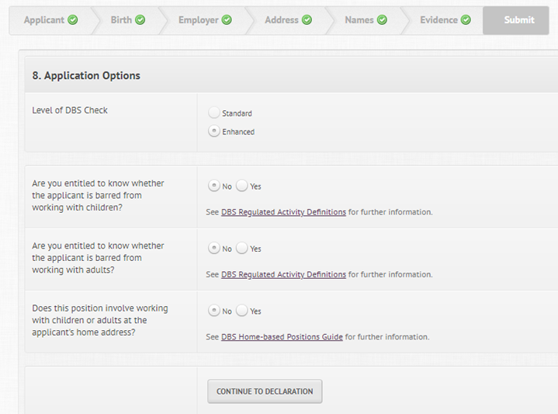

Step 5
You will now get through to the declaration page, please scroll down to the declarations by the nominated person/ ID checkers. You will be required to confirm the boxes and enter your name.

Step 6
The submission has now been completed; you can track the applications progression, find the application reference number and see when the certificates are completed through your dashboard at the top of the page.
Step 6
Now the application has been completed you may receive an E certificate that unless stated will allow you to view the certificate straight away on email. If something is disclosed they will ask you to wait to view the document, please ensure you ask volunteers to bring their certificate in if you are unable to view the E-certificate. Hopefully a volunteer’s application will read as follows:
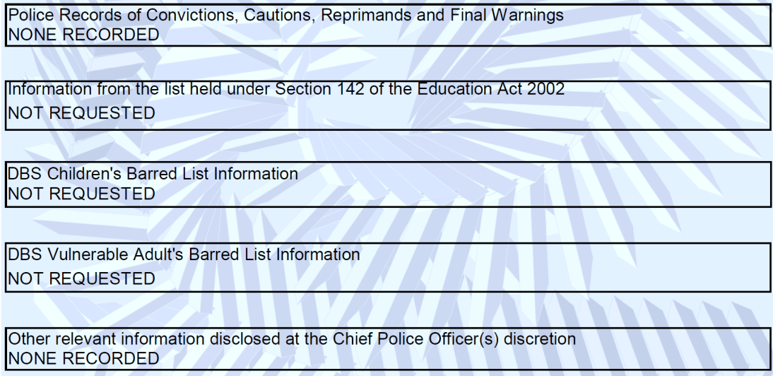

Whereas below will show the level of check required by those who are in a position of regulated activity and the role is described or equivalent to: Coach, Session Leader / Organiser, Centre / Yard Manager, RDA Whip and the role requires the individual to work with children. If a volunteer at the group becomes a coach or similar they will then be liable to have another DBS application done under the higher level.
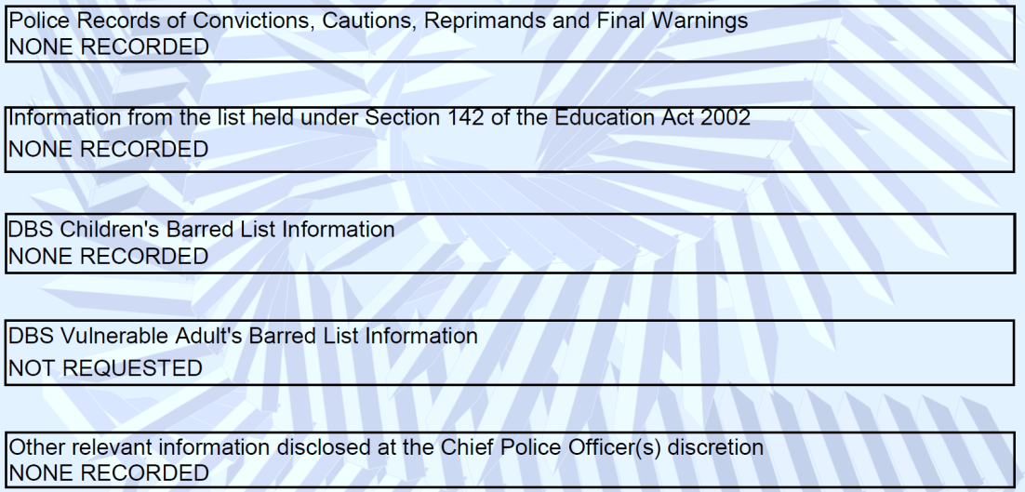

Please note that if an applicant does not receive their certificate within 19 days of the issue date they will have to contact DBS, due to the confidential nature of the certificate, to discuss getting a reprint. More information on this can be found at:
https://www.gov.uk/government/publications/dbs-certificate-reprint-guide/dbs-certificate-reprint-guide

It is also very useful to encourage your volunteers to join the update service. This will mean in three years the volunteer will not have to resubmit a new application they can just complete an update service form, giving you permission to check the status of the certificate online.

The benefits of the update service include:
- Free for volunteers
- Certificate is transferable across multiple organisations
- Less time filling in forms
- You can have multiple certificates managed from one area

To join the Update Service please visit:
https://secure.crbonline.gov.uk/crsc/apply?execution=e1s1

