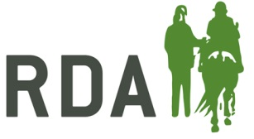
Getting Started Equine Assessment & Induction

To be completed by a suitably qualified Group Coach or Equine Manager

EQUINE NAME
Assessment (To be initialled when completed)
Up-to-date weight chart completed
Tack checked that it still fits
Feet checked by farrier, especially if shoes were removed during down time
Induction (Trainer to put YES, NO or NA, depending on the level or work required in the sessions)
Accepts being led both sides
Accepts side walkers
Accepts rider movement
Accepts rider noises
Accepts ramp mounting and dismounting / block mounting
Accepts crutches, canes and walkers
Accepts wheel chair transfers
Obeys voice commands “Halt” “Walk” “Trot” and “Canter”
Lunges well, both directions in all paces
Lunges with riders on
Leads well and obeys voice
Obeys leg aids and steers well
Accepts special adapted equipment
Accepts COVID-19 environment e.g. masks and sanitisers
Trainer to initial; confirming equine is ready for RDA sessions
Name |  | Signature

