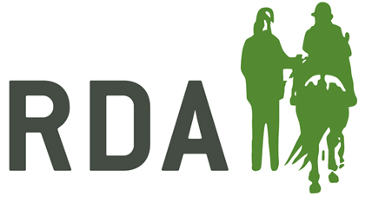
COVID-19 ARENA HIRE CONSENT FORM

GROUP NAME:

HIRER NAME:

The measures necessary to minimise the risk of the infection need to be observed by everyone using our arena.
In preparation for getting started again after lockdown the Trustees have:-
- Ensured that the venue has been cleaned, with all hard surfaces and equipment sanitised.
- Displayed signs on site to remind everyone of the need for social distancing and thorough hygiene regimes.
- Taken supplies of sufficient soap/sanitising products and disposable hand towels to allow regular hand washing.
By hiring our arena and signing this form you are confirming that you (and any others attending) are not considered to be clinically extremely vulnerable or needing to self-isolate and acknowledge that trustees have taken all reasonable steps to reduce the risks to COVID-19 and agree to the following protocols: -
- You will ensure before hiring the arena that you are not displaying any COVID symptoms requiring self-isolation i.e. high temperature, a new persistent cough or a loss of taste or smell, or living with anyone with any of these symptoms.
- If symptoms are evident you will cancel your booking and stay at home.
- You will thoroughly sanitise your hands on arrival at the first point of entry to the yard, regularly during your visit and when leaving, with the products provided for this purpose.
- You will follow social distancing at all times remaining 2m/6 feet from others whilst on site.
- If you fall ill or display symptoms during or after your visit you will advise us immediately and follow government advice on self -isolation.
- The areas accessible to you whilst visiting are ……………………………………………………………….. Please use the products provided to sanitise all surfaces that you touch when using the toilet.
- We will also be leaving a half hour gap in between bookings to help with social distancing, and request that you spend the minimum amount of time at the yard before and after your booked session. Please only bring one other person with you who must also follow our conditions of hire during this time.

Signature |  | Date:

