**[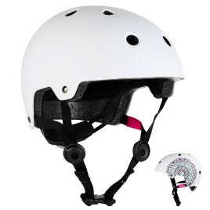](https://www.google.com/url?sa=i&rct=j&q=&esrc=s&source=images&cd=&cad=rja&uact=8&ved=2ahUKEwjvy8nrmbrcAhVKUhoKHXuJDjkQjRx6BAgBEAU&url=https://www.oxelo.co.uk/play7-mandala-inline-skating-skateboard-scooter-helmet-white-id_8400140&psig=AOvVaw1OHlWGnHRW8p5UN4SvJc89&ust=1532606346915055)Examples of Alternative Hats**

[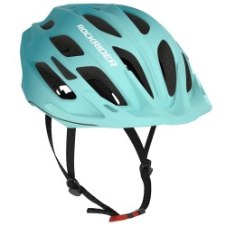](https://www.google.com/url?sa=i&rct=j&q=&esrc=s&source=images&cd=&cad=rja&uact=8&ved=2ahUKEwjZusSXmrrcAhUJyxoKHR3kBWEQjRx6BAgBEAU&url=https://www.decathlon.co.uk/C-595551-bike-helmets&psig=AOvVaw3VppNvBzM1XLzl4NiEf15I&ust=1532606477583995)

**Scooter Helmet**

**Cycle Helmet**

[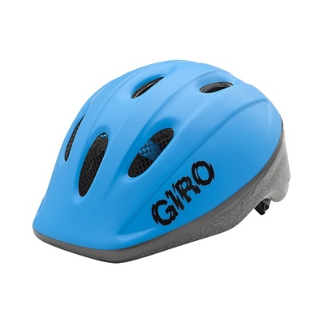](https://www.google.com/url?sa=i&rct=j&q=&esrc=s&source=images&cd=&cad=rja&uact=8&ved=2ahUKEwiMtpXjq7rcAhVBxoUKHSjiBWIQjRx6BAgBEAU&url=https://www.sportchek.ca/product/331723523.html&psig=AOvVaw3yt1YdKei9HsiGCBZ7Q8WT&ust=1532611188327787)[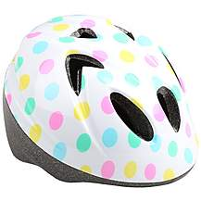](https://www.google.com/url?sa=i&rct=j&q=&esrc=s&source=images&cd=&cad=rja&uact=8&ved=2ahUKEwj0lvG7q7rcAhUL0RoKHdzDChAQjRx6BAgBEAU&url=https://www.halfords.com/cycling/bike-helmets/kids-bike-helmets&psig=AOvVaw33l2tCcNF3IyN8qeuB2GDU&ust=1532611113917577)

**Halfords Toddler Cycle Helmet**

**GIRO Rodeo Kids Bike Helmet**