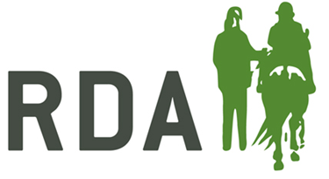
Online Disclosure services
Please read through this information before helping complete an online DBS application.
Step 1
Use the ID validation sheet, dated December 2017, to check your applicants ID. They must provide you with three forms of ID with one document from group 1 and two further documents from either group 1, 2a or 2b. If you are having trouble finding three documents for the applicant please email brandles@rda.org.uk where we will be able to talk through the options.

Please can the group complete and keep a copy of the ID validation form for their records (you do not need to send these in) as RDA UK may be doing spot checks to ensure that groups are checking identity documentation. You do not need to keep them for a long period of time 3 months is sufficient.

Step 2
Once the applicant has had their ID checked they can then be given the information sheet with the login details on to complete their form. Please add your unique password and username to the applicants guide sheet before giving to them. To avoid the applicant having to resubmit ensure they select ‘ENHANCED’ application and have enough time to complete as you cannot come back to a form half way through.

Step 3
After the applicant has submitted a form they then need to continue to payment via PayPal or inform the group to ask them to pay (depending on the agreement at your group). We are not aware a form is completed until we receive payment. This link will take applicants/ the group to the payment section if they need to pay for a form and didn’t do so straight after completing - http://www.rda.org.uk/dbsonline-applicationsuccess/

Step 4
The registered people at National office will then look through the form in case of errors and complete the submission. If Disclosure services find an error you will receive an email, please forward this to brandles@rda.org.uk so that the errors can be amended.

Step 5
Now the applicant has received their certificate please check that the information is correct and nothing has been disclosed. Hopefully a volunteer’s application will read as follows:
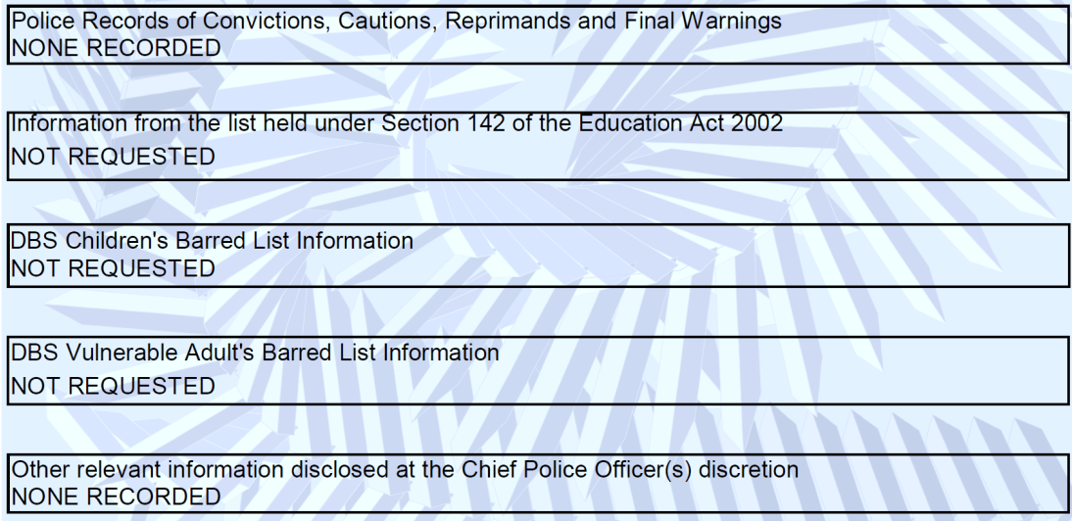

Whereas below will show the level of check required by those who are in a position of regulated activity and the role is described or equivalent to: Coach, Session Leader / Organiser, Centre / Yard Manager, RDA Whip and the role requires the individual to work with children. If a volunteer at the group becomes a coach or similar they will then be liable to have another DBS application done under the higher level.
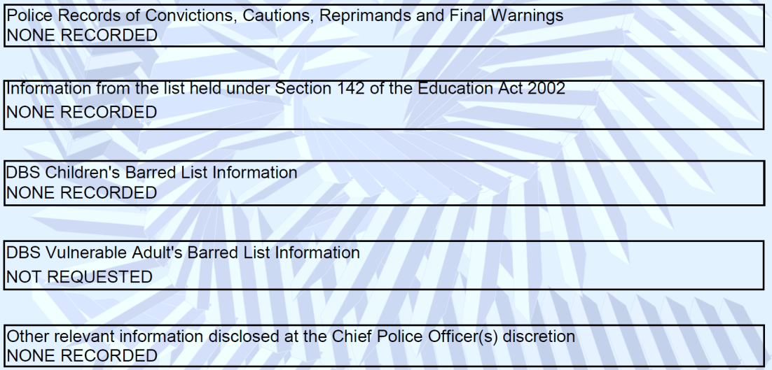

Please note that if an applicant does not receive their certificate within 19 days of the issue date they will have to contact DBS, due to the confidential nature of the certificate, to discuss getting a reprint. More information on this can be found at:
https://www.gov.uk/government/publications/dbs-certificate-reprint-guide/dbs-certificate-reprint-guide

If you wish to track the application you will be able to get the E reference number and D.O.B from national office:
Brandles@rda.org.uk
01926 476302

