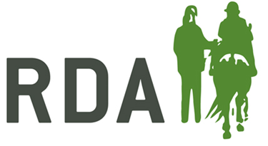
Online Disclosure services
Please read through this information before completing an online DBS application.
Please find your groups username & password listed below.

Username: RDA……………………….
Password: RDA………………………..

The site to use the username & password on is - www.disclosureservices.com

The web application form has a ten minute screen inactivity logout to protect your personal data. As there is no save option, please ensure that you have enough time to complete the application before starting. Once you log in you will need to read through the information from Disclosure services before continuing to application. Please have your identification documents to hand before you start.

Step 1
All applications have to be of an ‘ENHANCED’ level. This check’s for spent and unspent convictions, cautions, reprimands and final warnings plus any additional information held locally by police forces that’s reasonably considered relevant to the position applied for. This is the minimum level of check required by those, aged 16 and over, involved in an RDA session and supervised roles.

Step 2
When filling in your details there are often common mistakes made which cause delays in getting the application processed. The most common is missing forenames, including middle names. Names must be included IN FULL and this also applies to the full name history. Please do not use nicknames or abbreviations.

Step 3
Birth details

Step 4
Will ask for your Organisation / Employer's Details, please select the workforce type and your position at the group. You do not need to enter anything in the cost centre section.

Step 5
You will be required to give a five year continuous address history.

Step 6
Other Names – if you have previously been known by another name for instance a maiden name please enter here, remembering to include any middle names.

Step 7
The majority of applicants will be able to go route 1 by providing the ID checker with 1 document from Group 1, plus 2 from Group 1, 2a or 2b. These documents will already have been checked in order to obtain the password to start this application. You need to provide details of the documents used for the ID validation sheet for example, passport or driving licence number and start and finish dates (for driving licence these are dates 4a and 4b on the front of the card), bank/credit card name and date of statement, utility provider and date of statement.

Step 8
Finally, you will come to the submission page. This means that your application has been saved, it has not been submitted to Disclosure services at this point. In order to complete, please use the ‘click here’ button to pay for your application or provide the payee with the following link:
http://www.rda.org.uk/dbsonline-applicationsuccess/

Only when National office receives payment will they be able to log on to disclosure services to check through your application before completing the submission.

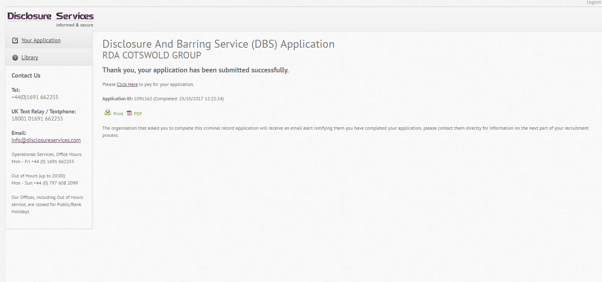

Certificates can take between one and two weeks to arrive after this. If you are concerned it has not arrived you can request a reprint if:
- Your DBS certificate was issued over 19 days ago, but you haven’t received it. You can find out the date your certificate was issued on through online tracking using your D.O.B and your form reference number which can be given to you from National office
- the reprint request has been made within 3 months (93 days) of the date of issue of your certificate
For more information on this please visit:
https://www.gov.uk/government/publications/dbs-certificate-reprint-guide/dbs-certificate-reprint-guide

Please show your certificate to the safeguarding officer at your group

