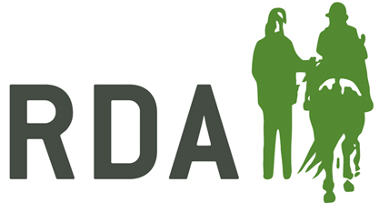
Getting Started
TRUSTEE CHECKLIST

Before the Group is able to restart its sessions, trustees must feel confident that the right preparation has been completed, and that the Group can continue to operate within current
COVID-19 requirements.
This checklist is to be completed by the Group Chair, or suitably designated trustee.
Before completing this form the group should go through “Guidance Notes” and the questions in “Getting Started ARE YOU READY?” taking action as required.
Action Undertaken | Yes/No
The Group has answered yes to all questions relating the VENUE
The Group has answered yes to all questions relating to the EQUINES
The Group has answered yes to all questions relating to the VOLUNTEERS / STAFF
The Group has answered yes to all questions relating to the COACHING SESSIONS
The Group has answered yes to all questions relating to the PARTICIPANTS
A COVID-19 Risk Assessment has been completed
Signed Covid-19 Consent Forms received from volunteers, staff and participants
If you have said No to any aspect listed, but still feel ready to re-start, please provide information below:-
Additional Information…….

Completed by:
I confirm that all relevant work has been undertaken and the Group is ready to start sessions.
RDA Group:
Name: |  | Position at Group:
Signature |  | Date:
A copy of this checklist, along with a completed Covid 19 Risk Assessment, must be sent to Director of Operations at info@rda.org.uk or National Office, Lowlands Equestrian Centre, Old Warwick Road, Shrewley, CV35 7AX

