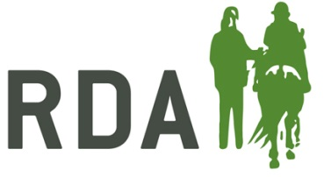
High Performance Coach of the Year
A coach who is coaching someone at National Championships level; competing and working towards Para levels
NOMINATION FORM
Nominator Details (your details) – Information required for acknowledgements and queries
I am making this nomination - Please circle as appropriate | On behalf of my RDA Group  As an RDA Volunteer  As an RDA Participant  As a parent/carer  As a teacher/TA of a participant  Other description – please state
Nominator’s full name and title

Preferred contact information

Nominee details
Name of Nominee
Name of RDA Group & Coaching Qualification
Approx. age of nominee | Please circle appropriate  16-30  31-55  56 above | Does your nominee know you have submitted this nomination?  Yes / No
Reasons for nomination in a max of 400 words: please give as much information as you can by answering the questions below about your nominee’s impact on RDA at Group, County, Region or National level.
Personal characteristics should be included, for example:
- Impact
- Dedication
- Leadership
- Positive attitude

Please note that nominations are presented to the judges as they are submitted and marks may be lost if the content is unclear.

Name of Nominee
To what level is your nominee coaching?

What qualities does your nominee evidence when in RDA? (please provide examples)

Please provide examples of the impact your nominee has on participants, including any resultant progress towards para and/or competition results:

CLOSING DATE FOR RECEIPT OF NOMINATIONS – 6th September 2019
Please return to: RDA, Lowlands Equestrian Centre, Old Warwick Road, Shrewley, Warwickshire, CV35 7AX
For further information or help, please contact Alex Walker on
01926 405971 / awalker@rda.org.uk

