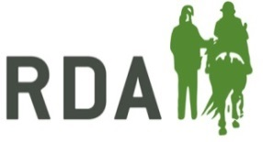
RDA HOLIDAY GRANTS 2018

The RDA Holidays Committee is very pleased to be able to make funds available for grants to RDA Groups & National Holidays – thanks to the support of a donor. The grants can help a group to organise an RDA holiday or day out for riders in their group, county or region as well as being able to support National Holidays.

Please note, unfortunately we cannot make a grant out to an individual. It must be for the group or national holiday for the benefit of RDA riders or drivers.

The grants:-

- You must complete the attached application form in full.

- The grant can be used to cover up to 50% of the cost to run a holiday/day out, to a maximum of £250 per grant.

- The application form must be accompanied by an overview of the group’s current accounts and/or a proposed budget for the day out/holiday.

- We are unable to make grants to groups where the reserves are more than 2 years running costs, unless there is a specific (and stated) reason why this is the case.

- Where we make a grant, we may ask to use your group or the funded project for publicity, to demonstrate the value of such funding.

- The group will get confirmation of their grant status by 30th April.

- Payment will be made after the holiday has completed upon photographic/written account of holiday/day out has been submitted.

- Grants will not be made to groups who have received an RDA Grant of more than £3,000 in the last 18 months.

- Grants are only available to full member Groups of RDA or National Holidays. Transitional Groups and Accessibility Mark Centres are not eligible.

- This grant is for RDA Groups or National Holiday Organisers to organise a day out or holiday for RDA riders. If you are applying to help one or more of your riders to attend a National Holiday, there is a separate grant for this.

As stated, the funds are being given to help enable your group to participate in RDA holidays/days out in some way. This fund cannot be used for general running costs.

The application form can be found below/overleaf.

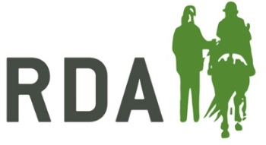
RDA HOLIDAY GRANT
APPLICATION FORM 2018

Applications will only be accepted from RDA Groups & National Holidays, not from individuals within RDA. The purpose of the award is to provide the opportunity for groups to be able to organise their own day out or residential holiday for the riders/drivers of their group. The award will be to the maximum of £250.

Please complete this form in block capitals.

GROUP NAME

GROUP REGION

Name of Applicant/Organiser:

Postal Address:

Telephone Number:

Email:

Date of the day out/holiday (must be before Dec 2018):

Number of Riders/Drivers attending:
Please give a brief report to support your application. Please indicate where you are going, what activities you will be taking part in, whether the riders/drivers be learning a new skill. Attach any photos or additional information to help support your application.

 | Name | Signature
Applicant/Organiser

Group Trustee

Date

