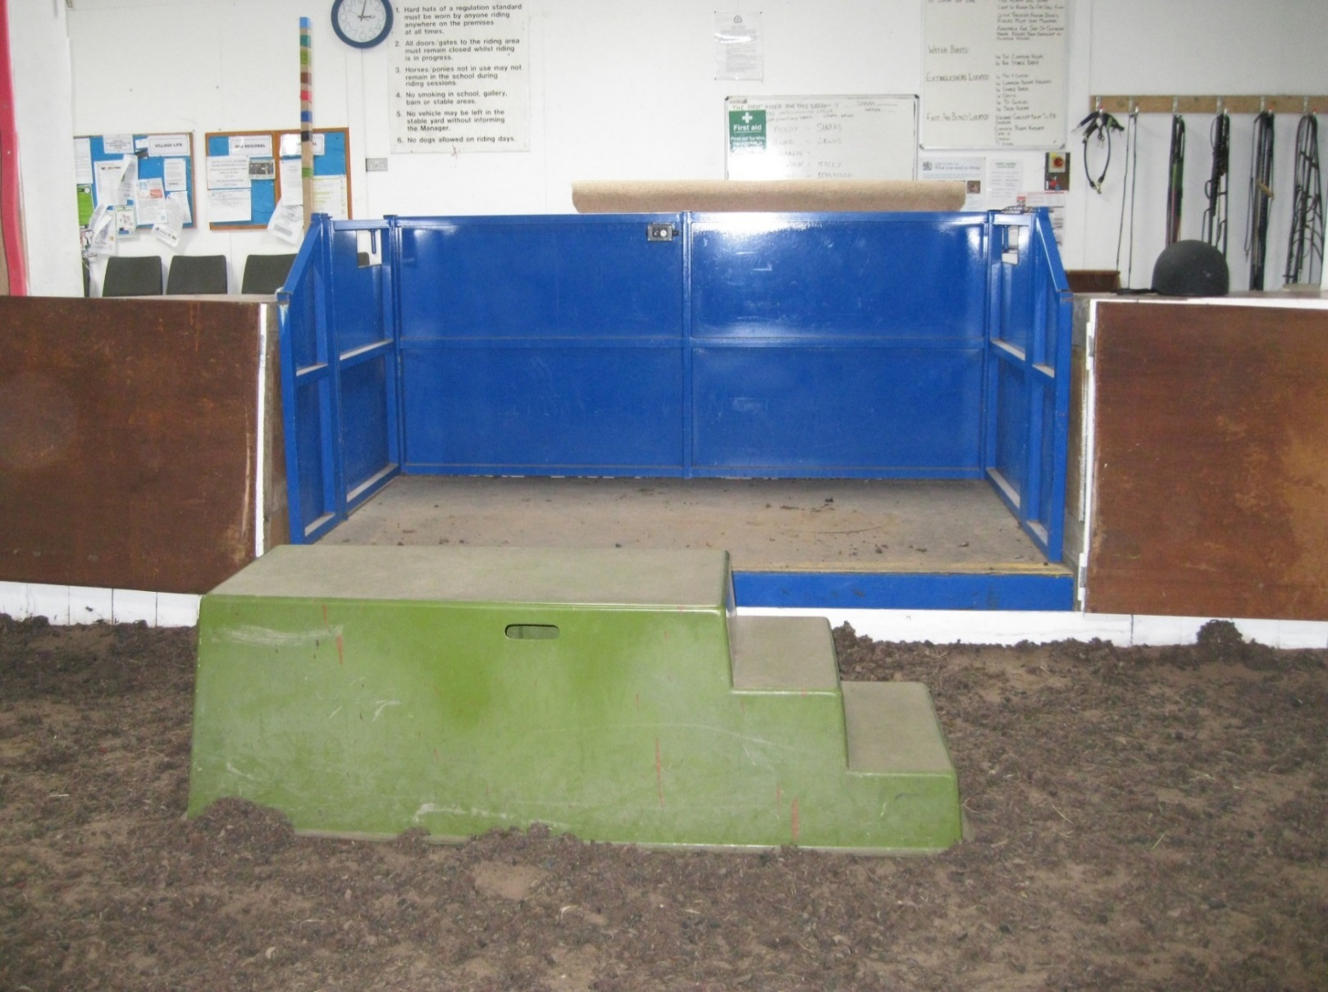

**Hydraulic Mounting Ramp along with a Martello block – Clwyd Special Riding Centre**