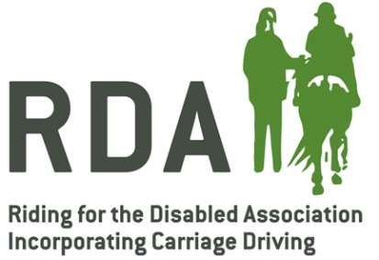
RDA Re-imbursement Vaccine Completion Form
Section A – Veterinary Surgeon – I certify that I have administered:
(no. of doses) of Equilis Prequenza batch number
(no. of doses) of Equilis Te batch number
(no. of doses) of Equilis Prequenza Te batch number
To equines in true use with the RDA group stated below. These were certified as being in regular and fair use for the RDA.
Signed Vet Surgeon on (date)

Name Block capitals

Address

Tel No. Email

Section B – Trustee of the group
I certify that we maintain a list of equines so injected and shall, ensure to the best of the group’s ability, ensure that the immunisation programme is maintained.
Signed a Trustee on (date)
Name Block Capitals
Address

Tel No. Email
Once completed a copy of this form should be retained by the RDA group and a copy posted to:
Customer Services, MSD Animal Health, Walton Manor, Walton, Milton Keynes, Buckinghamshire, MK7 7AJ

MSD will collate the completed claim forms, contact the practice and make arrangements for reimbursement through a BACS payment.

