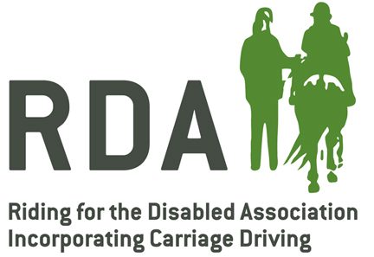
Equine Influenza and Tetanus (Flu&Tet) Claim Form
Please check that any vaccinations administered are supplied by one of the pharmaceutical companies supporting this reimbursement scheme.

Section A – Veterinary Surgeon

I certify that I have administered (number of doses)

Of (name of vaccine)

To equines in true use with the RDA group stated below. These were certified as being in regular and fair use for the RDA.

Signed Vet Surgeon on (date)

Name Block capitals

Address

Tel No. Email

Section B – Trustee of the group
I certify that we maintain a list of equines so injected and shall, ensure to the best of the group’s ability, ensure that the immunisation programme is maintained.
Signed a Trustee on (date)
Name Block Capitals
Address

Tel No. Email
Once completed this form should be retained by the RDA Group and a copy emailed to johanna.gaterwillats@Merial.com or posted to Merial Animal Health Ltd, Sandringham House, Sandringham Ave, Harlow, Essex CM19 5QA.

