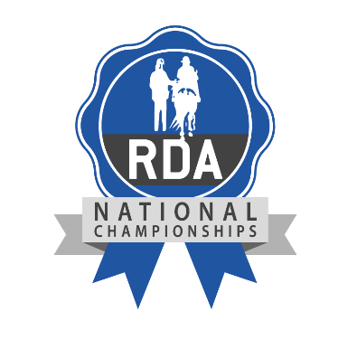

MUSICAL RIDE/CARRIAGE DRIVE

DVD COMPETITION 2020

REGIONAL ROUND ENTRY FORM

Group:
Region:

Group Representative Name:

Address
 | Postcode:
Telephone (Day): | Email Address:

(Please tick appropriate class)
Class 19 : Musical Drill Ride - Led
Class 20 : Musical Drill Ride - Unled
Class 21 : Musical Drill Drive
Class 22: Musical Drill Ride - Overseas
Performance Title:

Names of Riders or  Carriage Driver/s: | 1. |  | 2.
3. | 4. |  | 5.
6. | 7. |  | 8.

(THERE IS NO ENTRY FEE FOR THIS ROUND OF THE COMPETITION)

All DVDs must be clearly labelled with the class, title of the Ride or Carriage Drive, the name of the Group and Region. All entries must have a fully completed entry form.
Rider entries should be sent to your Regional Coach and Carriage Driving entries to your Regional Driving Rep.
The safe conveyance of the DVD is the responsibility of the Group concerned.

The closing date for all entries to the Regional Judging Round is

Wednesday 27th May 2020

LATE ENTRIES WILL NOT BE ACCEPTED

