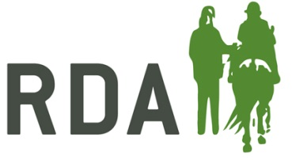

NATIONAL HOLIDAYS
GRANT APPLICATION FORM 2018

Applications will only be accepted from RDA Groups, not from individuals within RDA. The purpose of the award is for groups to provide the opportunity for one or more of their riders to attend an RDA National Holiday, which will help develop their skills or overall experience back in their group sessions. The awards are up to the maximum value of £250.

If the application is successful and is made on behalf of a rider to attend a National Holiday then the payment will be sent to the holiday organiser of the holiday they are hoping to attend. The payment will be made under the riders name and off-set against their place.

Please complete this form in block capitals.

GROUP NAME

GROUP REGION

Name of Applicant:

Postal Address:

Telephone Number:

Email:

NATIONAL HOLIDAY NAME & DATE:

Please give a brief report to support your application. Please include the name, age and experience of the rider/s that would like to attend the holiday and how they would benefit from attending the holiday.

 | Name | Signature
Applicant

Group Trustee

Date

Please return the completed form to the Holidays Coordinator at RDA National Office before 31st March 2018

