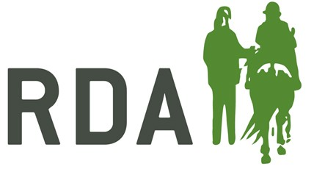
RDA Awards 2021 Nominee Form

Nominator Name
Nominator Phone Number
Nominator Email Address
Nominator Region and Group

Nominee Name
Nominee Region and Group

I am submitting this nomination on behalf of: (Please circle)
My RDA Group
As an RDA Volunteer
As an RDA participant
Other (Please Specify)
As a parent or Carer of an RDA Participant
As a teacher of an RDA Participant
Does this person know you are nominating them? (Please circle) Yes No
Which category are you nominating them for? (Please circle)
Young Volunteer of the Year Award (Age 12-18)
Volunteer of the Year Award (Age 18+)
Horse/Pony of the Year Award
Participant of the Year Award
RDAUK Volunteer of the Year Award
Reason for nomination:
Award Criteria: www.myrda.org.uk/assets/2021_RDA_Awards_Criteria.docx
For support on writing citations please see www.myrda.org.uk/assets/Citations_For_Awards.pdf

