[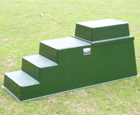](http://www.google.com/url?sa=i&rct=j&q=&esrc=s&source=images&cd=&cad=rja&uact=8&ved=2ahUKEwicnamjlbjdAhWMzYUKHZy0DfEQjRx6BAgBEAU&url=http://www.martelloplastics.co.uk/mounting-blocks.html&psig=AOvVaw1BAm6xb1dZvXnOtxIXgVJ1&ust=1536934424094094)[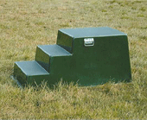](http://www.google.com/url?sa=i&rct=j&q=&esrc=s&source=images&cd=&ved=2ahUKEwjFyJqFlbjdAhWLyoUKHXl2CqQQjRx6BAgBEAU&url=http://www.martelloplastics.co.uk/mounting-blocks.html&psig=AOvVaw1BAm6xb1dZvXnOtxIXgVJ1&ust=1536934424094094)[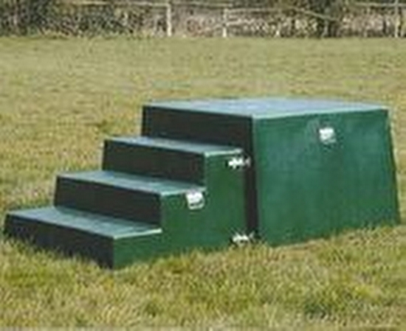](http://www.google.com/url?sa=i&rct=j&q=&esrc=s&source=images&cd=&cad=rja&uact=8&ved=2ahUKEwi9xNjOlbjdAhUNrxoKHZX0DaAQjRx6BAgBEAU&url=http://www.tradepages.co.uk/plastics-and-rubber/mould-manufacture/products/horse-mounting-blocks-2394.asp&psig=AOvVaw1BAm6xb1dZvXnOtxIXgVJ1&ust=1536934424094094)

**Martello Mounting Block with additional top on**

**Large Martello Block**

**Standard Martello Mounting Block**