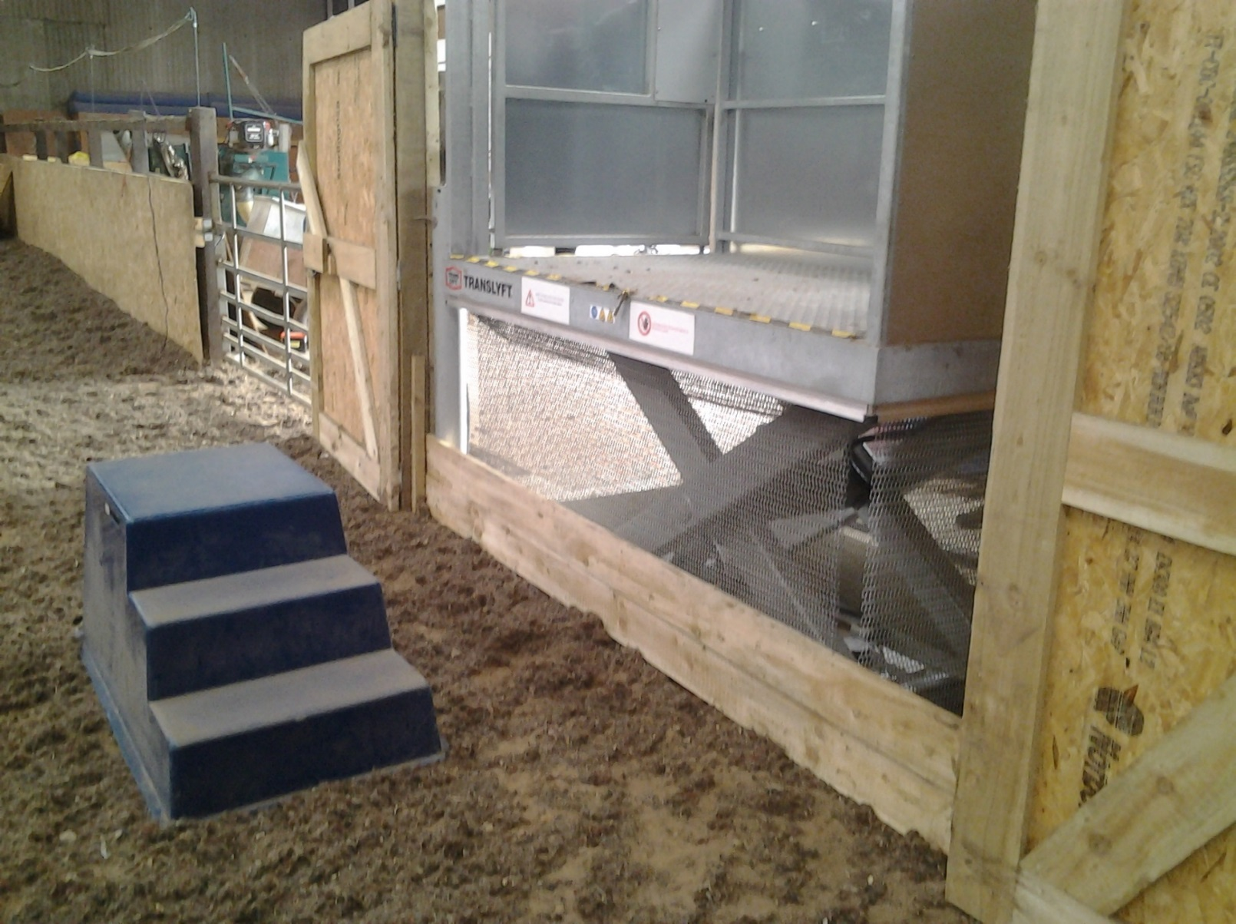

**Hydraulic Platform with Martello block - Stratford RDA Group**