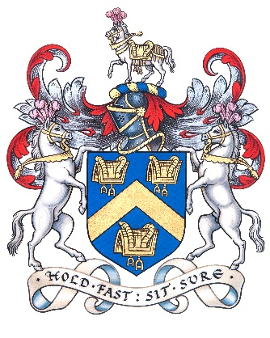
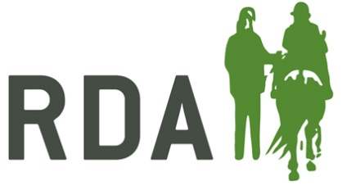
RDA COACH QUALIFICATIONS PATHWAY

ASSESSMENT
- 1 Coaching Session
- 1 Coach the Coach Session
- 1 Equine Assessment (lunging or ridden)
MODULES
ADVANCED
COACH CERTIFICATE
Practical
1 Coaching
2 Horse and Rider Biomechanics
3 Coach the Coach
ASSESSMENT - 1 RDA Group Session and/or
- 1 RDA Individual Session
- 1 Equine Assessment
COACH CERTIFICATE
MODULES
Theory Practical
1 Pre-Assessment 1 Coaching
Checklist 2 Horsecare & Knowledge 2 Safeguarding 3 Therapy / Medical
COACH IN TRAINING

Pre-coach Training Session: Receive “Coaching Passport”

MODULES

Theory Practical
- Disability Awareness - Mounting / Dismounting
- Equine Knowledge - Preparing and Assisting
RDA Sessions
GREENCARD HOLDER

