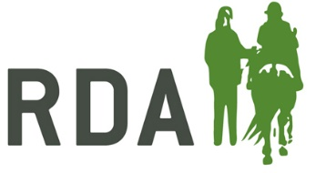
RDA DRESSAGE
Grade 6 Freestyle to Music (2020) walk, trot & canter
The Scale of the marks is as follows:  10 Excellent 4 Insufficient  9 Very Good 3 Fairly Bad  8 Good 2 Bad  7 Fairly Good 1 Very Bad  6 Satisfactory 0 Not Performed  5 Sufficient | Allow 9 minutes between tests  Time of test 4mins 30 secs – 5mins 30 secs  Arena 20m x 40m

Piaffe, passage, single flying changes, sequence changes and canter pirouettes are not allowed in this test.

 | Compulsory Movements | Max. Marks
1. | Halt at the beginning of the test on the centre line | 10
2. | Halt at the end of the test on the centre line | 10
3. | Circle left 10m diameter in medium walk | 10
4. | Circle right 10m diameter in medium walk | 10
5. | Walk allowing the horse to stretch on a longer rein (minimum 20m) | 10
6. | Circle left 20m in working trot | 10
7. | Circle right 20m in working trot | 10
8. | Circle left 20m in working canter | 10
9. | Circle right 20m in working canter | 10
10 | Transitions within and/or between paces | 10
Total for technical execution |  | 100
1. | Rhythm, suppleness and energy | 10 x 2
2. | Harmony between rider and horse | 10 x 3
3. | Choreography, use of arena, inventiveness | 10 x 3
4. | Musical interpretation | 10 x 2
Total marks for artistic presentation |  | 100

ARTISTIC MARKS

Half marks may be given.

For each disallowed movement performed deduct 8 marks from the artistic mark.

If test less than 4 mins 30 secs or more than 5 mins 30 secs, deduct 0.5% from the artistic total.

In case of two competitors having the same final score, the one with the higher marks for the artistic impression will be the winner. If the artistic marks are the same there will be a tie between those competitors.

