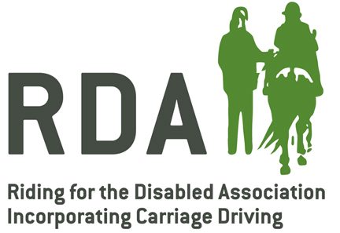

GROUP PRIVACY NOTICE
<Group Name>

What information do we collect about you?
We collect information about you when you complete relevant forms for us, including the rider/driver application form and the volunteer application form.

How will we use the information about you?
We will use the information about you to administer the RDA group ride schedules. We may pass the information about you to Riding for the Disabled Association incorporating Carriage Driving, the national body. Limited, anonymised information may be passed to RDA for analysis in the Tracker. We will not disclose any information about you to any company other than noted above, or if required to do so by law.

Marketing
We would like to send you newsletters and other information about how you can support the RDA group. If you have consented to receive marketing, you may opt out at a later date. You have a right at any time to stop us from contacting you for marketing purposes.

Access to your information and correction
You have the right to request a copy of the information that we hold about you.
We want to make sure that your personal information is accurate and up to date. You may ask us to correct or remove information you think is inaccurate.

Retention of data
Once you are no longer involved with the RDA group, we will securely retain your data for 3 years for adults and 3 years after a child reaches the age of 18.

How to contact us
If you have any questions about our privacy policy or information we hold about you, please contact us at:

