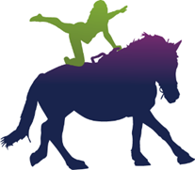

RDA VAULTING FILMED COMPETITION 2020
PERMISSION TO FILM & PHOTOGRAPH

(To be included with all entries)
This form must be completed for every Vaulter who is photographed/ filmed for the RDA Filmed Vaulting Competition.

Vaulter’s name: ____________________________________________________________________________

Group name: ____________________________________________________________________________

By signing below, you are giving express permission to be photographed/filmed for the RDA Filmed Vaulting competition.
Films and/or still images from the competition may be used for publicity purposes such as, but not limited to: Training events, publicity leaflets and short films, RDA magazines and also use on the RDA website.
Occasionally the images may be used, in accordance with the RDA Social Media Policy, on RDA Twitter and/or RDA Facebook pages.
Please indicate your permission or otherwise below, by ticking one of the following options:
 I give permission for the photographs/films to be used by RDA for publicity purposes as described above.

 I specifically DO NOT give permission for the photographs/films to be used by RDA and for publicity purposes as described above.

Signed: _____________________________________________________________________________
Vaulter (if under 18) or parent/ guardian /carer (please delete as applicable)

Print name: ___________________________________________________________________________

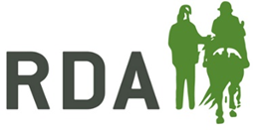
Date: ___________________________________

