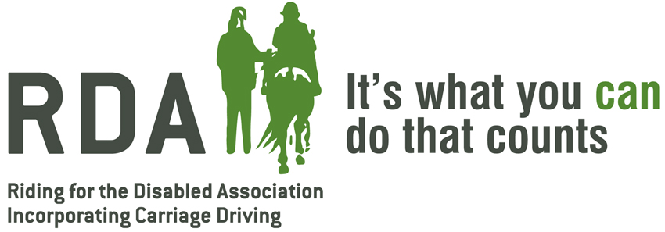

Regional Equine Advisor Training Day
Berkswell & Balsall Rugby Club, Honiley Road, Meer End, Nr Balsall Common
Warwickshire, CV8 1NQ
Tuesday 21st November 2017
10am – 4pm
This day has been put together for all current Regional Equine Advisors or for those who are interested in taking on the role within their region.
Programme
9.30am -10am – Teas & Coffee’s available
10am – 12.30pm – Discussion & Group work around the topics below
- Policies
- Myths
- Practices
- Resources available
- Free Vaccine Scheme
- Training in your region
12.30pm – 1pm – Lunch
1pm – 3pm – Guest Speaker TBC
3pm – 4pm – Site visit to the National Training Centre, Lowlands Farm.

Lunch will be provided, please state any dietary requirements upon your reply.
Please reply to Lottie Dronfield via the slip below or by emailing her at ldronfield@rda.org.uk
Regional Equine Advisor Training Day – Berkswell & Balsall Rugby Club – Tuesday 21st November

Name_______________________________________ Region________________________________
Contact Number:______________________________ Email__________________________________
Dietary Requirements____________________________________

