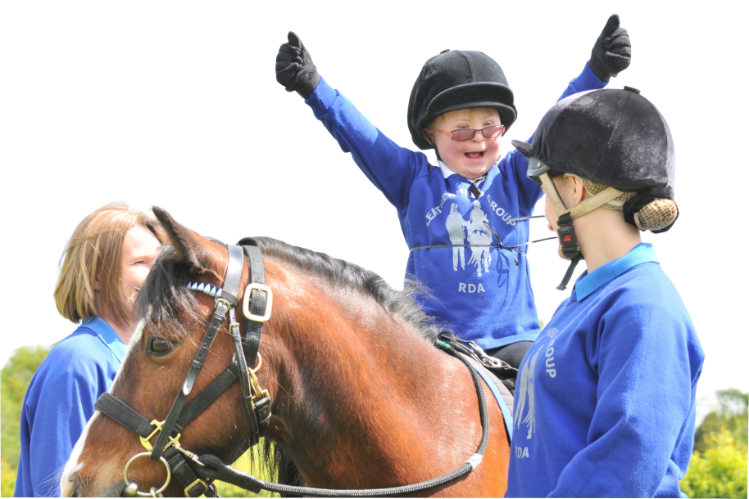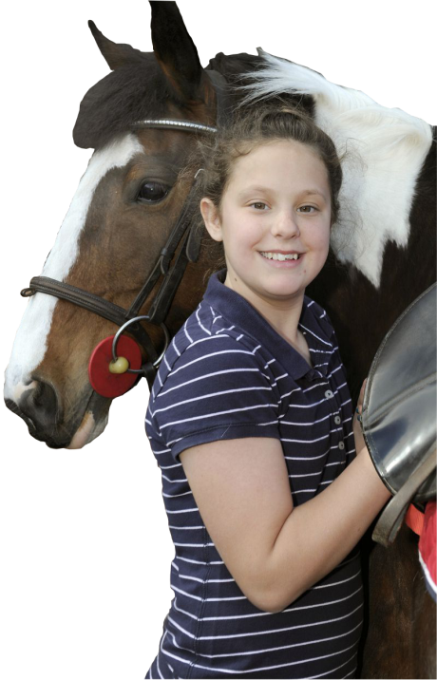

**RDA National Office:**

Stef Brazier E: [sbrazier@rda.org.uk](mailto:sbrazier@rda.org.uk) **Tel: 01926 476302**

Marisa Bretherton-Mackay E: [marisa@rda.org.uk](mailto:marisa@rda.org.uk) **Tel: 01926 405973**

**Helplines:**

NSPCC Child Protection Helpline **0808 800 5000**

Childline **0800 1111**

Family Lives **0808 800 2222**

**GROUP**

**SAFEGUARDING OFFICER**

Place Photo of Group Safeguarding

Officer here.

NAME: ………………………………………………………

TELEPHONE: ………………................................

RIDE DAYS: ………………………………………………..

