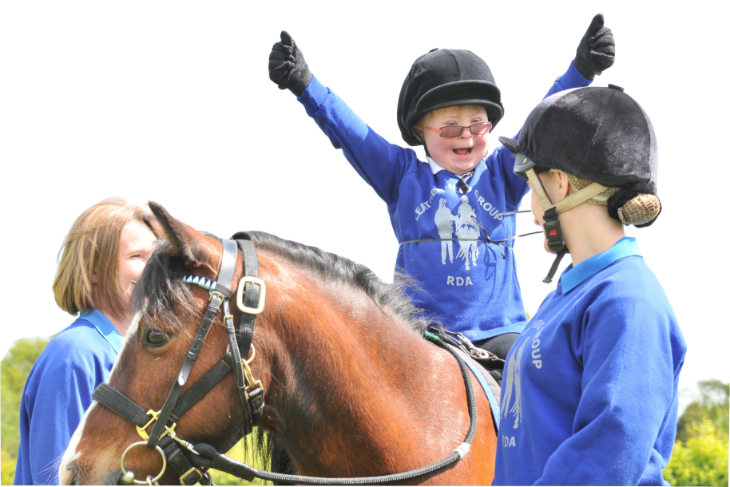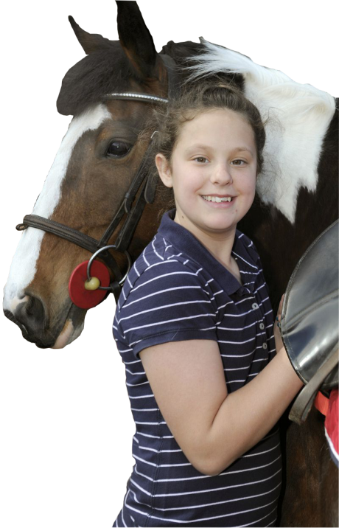

Place Photo of Safeguarding

Officer here.

**RDA National Office:**

Lottie Dronfield [ldronfield@rda.org.uk](mailto:ldronfield@rda.org.uk) **01926 405972**

Claire Milican [cmilican@rda.org.uk](mailto:cmilican@rda.org.uk) **01926 405969**

**RDA Emergency Out of Hours – 07599 236036**

**Helplines:**

NSPCC Child Protection Helpline **0808 800 500**

Childline **0800 1111**

Parentline Plus **0808 800 2222**

NAME: ………………………………………………………

TELEPHONE: ………………................................

RIDE DAYS: ………………………………………………..

**(GROUP)**

**SAFEGUARDING OFFICER**

