**COACHES DEVELOPMENT WORKBOOK & ACTIVITY GUIDE**



Name:

**CONTENTS**

**1. HEALTH AND SAFETY**

**2. THE RDA COACH**

**3. VOLUNTEER MANAGEMENT**

**4. HORSE CARE & STABLE MANAGEMENT**

**5. TEACHING THEORY**

**6. MEDICAL KNOWLEDGE**

**7. RDA KNOWLEDGE**

**8. CASE STUDIES**

**4. HORSE CARE & STABLE MANAGEMENT**

 This section is based on the British Horse Society stage II syllabus. You will cover:

1. Horse psychology

2. Anatomy & physiology

3. Horse health

4. Watering & feeding

5. Shoeing / care of foot

6. Saddlery

7. Grooming

8. Fittening / roughing off

9. Lungeing

10. Clothing

11. Travelling

12. Clipping & trimming

13. Stable design

14. Grassland management

**Objectives**

Your objective is to complete in detail each part

giving you a wider knowledge of horse care and

management, leaving you relatively competent to take care of horses on a daily basis.

**4. HORSE CARE & STABLE MANAGEMENT**

**PART 1 HORSE PSYCHOLOGY**

You will cover:

1. the horse’s natural lifestyle.

2. its instincts and reactions.

3. how to recognise and handle situations using a calm

approach to improve its well-being.

**Aims**

The aim of this part is to give you a thorough knowledge of the horse’s way of life enabling you to have a calm approach to improve its well-being.

**Objectives**

On completion of this part you should be able to:

• show a sound understanding of the horse.

• know how to deal with difficult situations.

• demonstrate a calm & effective approach.

**HORSE PSYCHOLOGY**

|  |
| --- |
| 1. List what horses are likely to do when frightened. |
|  |
|  |
|  |
|  |
|  |
|  |
| 2. What are the horse’s natural instincts when frightened? |
|  |
|  |
|  |
|  |
|  |
| 3. List what precautions you should take when introducing a new horse into the yard and RDA session. |
|  |
|  |
|  |
|  |
|  |

4. Write an observation report on horses including the following:

• out in the field (*with some time spent watching them*).

• being handled.

• being ridden.

• being used in a RDA Environment.

|  |
| --- |
|  |
|  |
|  |
|  |
|  |
|  |
|  |
|  |
|  |
|  |
|  |
|  |
|  |
|  |
|  |

|  |
| --- |
| 5. The horse has large, mobile ears that hear things long before we do. What else can the horse’s ears tell you? |
|  |
|  |
|  |
|  |
|  |
|  |
|  |
|  |
| 6. The horse’s eyesight is different. How may this affect his behaviour? |
|  |
|  |
|  |
|  |
|  |
|  |
|  |
|  |

**4. HORSE CARE & STABLE MANAGEMENT**

**PART 2 ANATOMY & PHYSIOLOGY**

This part will include:

1. Points of the horse.

2. Skeletal frame.

3. Outline digestive system.

4. Structure of the foot and its functions.

5. Position of the main internal organs.

**Aims**

The aim of this part is to give you a good understanding of how the horse’s body works and enable you to identify various parts of the horse. It will take a few months to be able to remember each part of the horse without help - practice makes perfect.

**Objectives**

On completion of this part you will be able to:

• identify parts of the horse.

• identify its skeletal frame.

• know how the horse’s digestive system works and identify each part.

• identify the structure of the horse’s foot and understand its function.

• identify where the main internal organs are.

**ANATOMY & PHYSIOLOGY**

|  |  |  |  |  |
| --- | --- | --- | --- | --- |
| 1. List all points of the horse. | | | | |
|  |  |  |  |  |
|  |  |  |  |  |
|  |  |  |  |  |
|  |  |  |  |  |
|  |  |  |  |  |
|  |  |  |  |  |
|  | | | | |
| 2. List the parts of the skeletal frame using the skeletal frame sheet | | | | |
|  |  |  |  |  |
|  |  |  |  |  |
|  |  |  |  |  |
|  |  |  |  |  |
|  |  |  |  |  |
|  | | | | |

|  |  |  |  |  |  |  |  |  |  |
| --- | --- | --- | --- | --- | --- | --- | --- | --- | --- |
| 3. List each part of the horse’s digestive system - starting with its: | | | | | | | | | |
| a) prehensile lips. |  | | | | |  | |  | |
|  | |  |  | | | |  | |  | |
|  | |  |  | | | |  | |  | |
|  | |  |  | | | |  | |  | |
|  | |  |  | | | |  | |  | |
|  | |  |  | | | |  | |  | |
|  | |  |  | | | |  | |  | |
| 4. List the main internal organs. | |  | |  | |  | |  | |
|  | |  | | |  |  | |  | |
|  | |  | | |  |  | |
|  | |  | | |  |  | |  | |
|  | |  | | |  |  | |  | |
|  | |  | | |  |  | |  | |
|  | |  | | |  |  | |  | |
|  | |  | | |  |  | |  | |
| 5. Draw the structure of the foot (internally & externally) and label each individual part. | |  | | |  |  | |  | |

|  |  |  |  |  |
| --- | --- | --- | --- | --- |
|  | | | | |
| 6. Write a short paragraph on the function of the foot. | | | | |
|  |  |  |  |  |
|  |  |  |  |  |
|  |  |  |  |  |
|  |  |  |  |  |
|  |  |  |  |  |
|  |  |  |  |  |
|  |  |  |  |  |
|  |  |  |  |  |
|  |  |  |  |  |

**ANATOMY & PHYSIOLOGY**

Observation sheet. Ask someone to go through the list with you.

|  |  |  |  |
| --- | --- | --- | --- |
| DATE | TASK | LEVEL | OBSERVER |
|  | Recognise points of the horse: |  |  |
|  | head |  |  |
|  | neck |  |  |
|  | body |  |  |
|  | quarters |  |  |
|  | legs |  |  |
|  | Recognise points of the skeletal frame: |  |  |
|  | head |  |  |
|  | neck |  |  |
|  | body |  |  |
|  | quarters |  |  |
|  | legs |  |  |
|  | Point out digestive system starting with prehensile lips. |  |  |
|  | Identify location of main internal organs. |  |  |
|  | Recognise the structure of the foot: |  |  |
|  | internally |  |  |
|  | externally |  |  |

**Points of the horse**

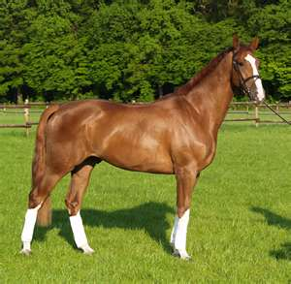

5

7

8

6

11

12

9

10

1

13

26

2

3

14

25

15

16

18

17

24

23

19

22

21

20

|  |  |  |  |  |  |
| --- | --- | --- | --- | --- | --- |
| 1. |  |  | 14. |  |  |
| 2. |  |  | 15. |  |  |
| 3. |  |  | 16. |  |  |
| 4. |  |  | 17. |  |  |
| 5. |  |  | 18. |  |  |
| 6. |  |  | 19. |  |  |
| 7. |  |  | 20. |  |  |
| 8. |  |  | 21. |  |  |
| 9. |  |  | 22. |  |  |
| 10. |  |  | 23. |  |  |
| 11. |  |  | 24. |  |  |
| 12. |  |  | 25. |  |  |
| 13. |  |  | 26. |  |  |

**Outline digestive system**

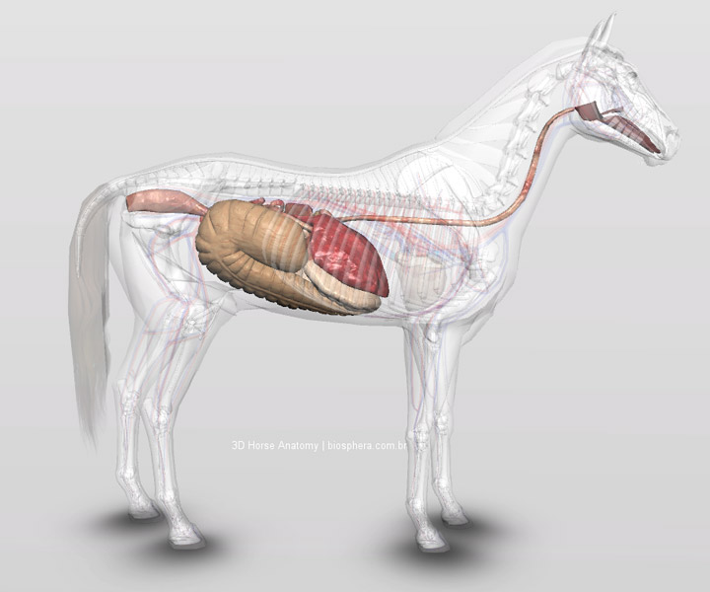

9

82

7

6

5

42

32

22

1

12

11

10

|  |  |  |  |  |  |
| --- | --- | --- | --- | --- | --- |
| 1. |  |  | 8. |  |  |
| 2. |  |  | 9. |  |  |
| 3. |  |  | 10. |  |  |
| 4. |  |  | 11. |  |  |
| 5. |  |  | 12. |  |  |
| 6. |  |  |  |  |  |
| 7. |  |  |  |  |  |

**Main internal organs**



3

5

6

4

1

2

|  |  |  |  |  |  |
| --- | --- | --- | --- | --- | --- |
| 1. |  |  | 4. |  |  |
| 2. |  |  | 5. |  |  |
| 3. |  |  | 6. |  |  |

**Parts of the skeletal frame**

1

2

3

4

5

6

7

8

9

10

11

12

13

14

15

16

17

18

19

20

21

22

23

24

25

26

27

29

30

31

32

28

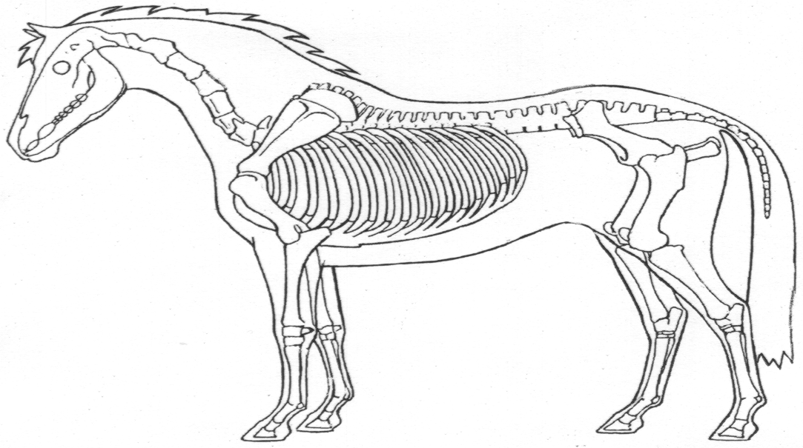

|  |  |  |  |  |  |
| --- | --- | --- | --- | --- | --- |
| 1. |  |  | 17. |  |  |
| 2. |  |  | 18. |  |  |
| 3. |  |  | 19. |  |  |
| 4. |  |  | 20. |  |  |
| 5. |  |  | 21. |  |  |
| 6. |  |  | 22. |  |  |
| 7. |  |  | 23. |  |  |
| 8. |  |  | 24. |  |  |
| 9. |  |  | 25. |  |  |
| 10. |  |  | 26. |  |  |
| 11. |  |  | 27. |  |  |
| 12. |  |  | 28. |  |  |
| 13. |  |  | 29. |  |  |
| 14. |  |  | 30. |  |  |
| 15. |  |  | 31. |  |  |
| 16. |  |  | 32. |  |  |

**4. HORSE CARE & STABLE MANAGEMENT**

**PART 3 HORSE HEALTH**

It will include:

1. recognising when a horse is lame.

2. treatment of minor wounds.

3. basic nursing.

4. when to call a vet.

5. worming.

6. Vaccinations and recording of.

7. dental care.

8. medical records.

**Aims**

The aim of this part is to give you an understanding of how to deal with the horse’s medical needs.

**Objectives**

On completion of this part you will be able to:

• Identify different types of lameness.

• be able to treat minor wounds.

• know how to nurse a sick horse.

• know when you cannot deal with the ailment that it is time to call a vet.

• understand worming - identify different worms and know their treatment.

• know when to have the horse vaccinated and why.

• know how regularly to have the horse dentist and why.

• understand the importance of medical records.

**HORSE HEALTH**

|  |  |  |  |  |  |  |
| --- | --- | --- | --- | --- | --- | --- |
| 1. List ten different causes of lameness. | | | | | | |
|  | a) |  |  | f) |  |  |
|  | b) |  |  | g) |  |  |
|  | c) |  |  | h) |  |  |
|  | d) |  |  | i) |  |  |
|  | e) |  |  | j) |  |  |
| 2. Describe how you would know when a horse is lame and how to identify the lame leg. (*Use a separate sheet to write this up*). | | | | | | |
| 3. List ten different minor wounds. | | | | | | |
|  | a) |  |  | f) |  |  |
|  | b) |  |  | g) |  |  |
|  | c) |  |  | h) |  |  |
|  | d) |  |  | i) |  |  |
|  | e) |  |  | j) |  |  |
| 4. State three ways to treat minor wounds. | | | | | | |
|  | a) |  |  |  |  |  |
|  |  |
|  | b) |
|  | c) |  |  |  |  |  |

5. Write a procedure on how to care for a sick horse.

|  |
| --- |
|  |
|  |
|  |
|  |
|  |
|  |
|  |
|  |
|  |
|  |
|  |
|  |
|  |
|  |
|  |
|  |
|  |
|  |

|  |  |  |  |  |
| --- | --- | --- | --- | --- |
| 6. For a horse what should be the normal: | | | | |
| temperature? | | |  |  |
| pulse? | | |  |  |
| respiration rate? | | |  |  |
| 7. How would you take a horse’s temperature? | | | | |
|  | | |  |  |
|  | | |  |  |
|  | | |  |  |
| 8. How would you take a horse’s pulse? | | | | |
|  | | |  |  |
|  | | |  |  |
|  |  |
| 9. How would you check a horse’s respiration? | | | | |
|  | | |  |  |
|  | | |  |  |
| 10. State briefly when you would call a vet. | | |  |  |
|  | | | | |
|  | | |  |  |

|  |  |  |  |  |  |  |
| --- | --- | --- | --- | --- | --- | --- |
| 11. List the different types of worm. | | | | | | |
|  |  |  |  |  |  |  |
|  |  |  |  |  |  |  |
|  |  |  |  |  |  |  |
| 12. List four different types of wormers and which worms they treat. | | | | | | |
| NAME | | TYPE OF WORM THEY TREAT | | | | |
|  | |  | | | | |
|  | |  | | | | |
|  | |  | | | | |
|  | |  | | | | |

|  |  |  |
| --- | --- | --- |
| 13 Name the main vaccinations given to horses. | | |
|  |  |  |
|  |  |  |
| 14. State what they cover and the frequency of vaccinations. | | |
| Name |  |  |
|  |  |  |
|  |  |  |
|  |  |  |
|  |  |  |
|  |  |  |
|  |  |  |
|  |  |  |
| Name |  |  |
|  |  |  |
|  |  |  |
|  |  |  |
|  |  |  |
|  |  |  |
|  |  |  |
|  |  |  |

15. Draw a diagram showing a worm cycle. (*Use this sheet*).

 16. State the Procedure for Worm Egg Counting



17. Design a worming program in the form of a chart. Indicate the type of wormer and the time of year. (*Use this sheet*).

|  |  |  |  |  |  |  |
| --- | --- | --- | --- | --- | --- | --- |
| 18. How often should your horse’s teeth be checked and rasped? | | | | | | |
|  |  |  |  |  |  |  |
|  |  |  |  |  |  |  |
| 19. List what effect it may have on the horse if it does not have its teeth properly cared for. | | | | | | |
|  |  |  |  |  |  |  |
|  |  |  |  |  |  |  |
|  |  |  |  |  |  |  |
|  |  |  |  |  |  |  |
| 20. State reasons for keeping medical records. | | | | | | |
|  |  |  |  |  |  |  |
|  |  |  |  |  |  |  |
|  |  |  |  |  |  |  |
|  |  |  |  |  |  |  |
| 21. Draw up a record sheet (A4 size) on which you can keep health records and include:    • date  • name of horse  • reason for vet visit  • any medication needed and dosage. | | | | | | |

22. Using the picture below indicate where you will find the

following:

laminitis

splints

capped elbow

capped hock

mud fever

thrush

ringbone

Sidebone

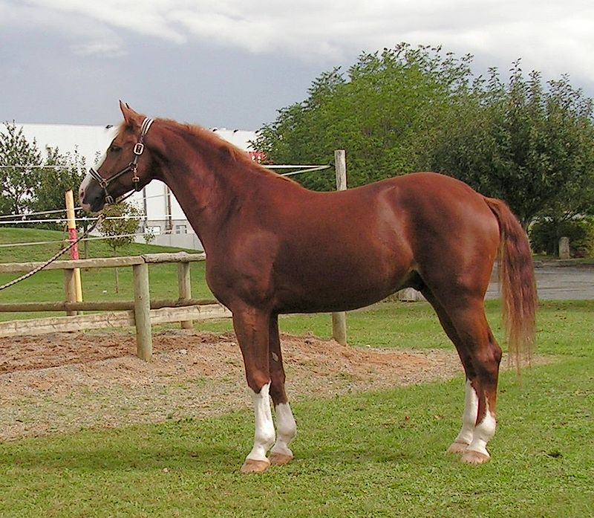

|  |
| --- |
| 23. What is colic and how will you deal with it? |
|  |
|  |
|  |
|  |
|  |

**4. HORSE CARE & STABLE MANAGEMENT**

**PART 4 WATERING & FEEDING**

It will include:

1. rules of feeding.

2. different types of feed.

3. feed values (i.e. proteins etc.).

4. how to feed old horses.

5. how to feed sick horses.

6. how to feed horses in work.

7. how to feed out at grass.

8. preparing cooked feeds.

9. feed charts.

10. hay and alternatives to hay.

11. water and watering systems.

**Aims**

The aim of this part is to enable you understand the dietary needs of the horse.

**Objectives**

On completion of this part you should be able to:

• identify feeds.

• understand their feed value.

• know how to feed horses out at grass and special cases e.g. old, sick and young horses.

• understand the importance of water.

• know the advantages & disadvantages of different types of watering systems.

**FEEDING**

|  |  |  |  |  |  |  |
| --- | --- | --- | --- | --- | --- | --- |
| 1. List five rules of feeding. | | | | | | |
|  | a) |  |  | f) |  |  |
|  | b) |  |  | g) |  |  |
|  | c) |  |  |  |  |  |
| 2. What would you feed an old horse and why? | | | | | | |
|  |  |  |  |  |  |  |
|  |  |  |  |  |  |  |
|  |  |  |  |  |  |  |
|  |  |  |  |  |  |  |
|  |  |  |  |  |  |  |
| 3. What would you feed a horse in medium work? | | | | | | |
|  |  |  |  |  |  |  |
|  |  |  |  |  |  |  |
|  |  |  |  |  |  |  |
|  |  |  |  |  |  |  |
|  |  |  |  |  |  |  |

8. Make up a feed chart using the horses on your yard as examples.

|  |  |  |  |  |  |  |  |  |  |
| --- | --- | --- | --- | --- | --- | --- | --- | --- | --- |
| 9. Identify eight different feed types and state their Nutritional values. | | | | | | | | | |
|  | | | | | | | | | |
|  | | **1** | |  | | **2** | |  | |
|  | Name | |  | | Name | |  | |  |
| Feed value | |  | | Feed value | |  | |
|  | | | | | | | | | |
|  | | **3** | |  | | **4** | |  | |
|  | Name | |  | | Name | |  | |  |
| Feed value | |  | | Feed value | |  | |
|  | | | | | | | | | |
|  | | **5** | |  | | **6** | |  | |
|  | Name | |  | | Name | |  | |  |
| Feed value | |  | | Feed value | |  | |
|  | | | | | | | | | |
|  | | **7** | |  | | **8** | |  | |
|  | Name | |  | | Name | |  | |  |
| Feed value | |  | | Feed value | |  | |

**HAY**

|  |  |
| --- | --- |
| 1. List three different types of hay and state their relative feed  values. | |
| a) |  |
|  |  |
| b) |  |
|  |  |
| c) |  |
|  |  |
| 2. State how you would feed hay / haylage. | |
|  |  |
|  |  |
|  |  |
| 3. State the benefits of feeding hay / haylage | |
|  |  |
|  |  |
|  |  |
|  |  |
|  |  |

**WATER**

|  |  |
| --- | --- |
| 1. What is the importance of water to the horse and why? | |
|  |  |
|  |  |
| 2. List three different types of watering systems and state their  advantages and disadvantages. | |
| a) |  |
|  |  |
|  |
| b) |  |
|  |  |
|  |  |
| c) |  |
|  |  |
|  |  |
| 3. When would you not give a horse water? | |
|  |  |
|  |  |
| 4. How would you give a horse water Immediately after work? | |
|  |  |

**Information search**

What would you feed a fifteen hands horse in medium work? Using this sheet, include:

• when you would feed,

• how much you would feed and

• what you would feed.

|  |
| --- |
|  |
|  |
|  |
|  |
|  |
|  |
|  |
|  |
|  |
|  |
|  |
|  |
|  |
|  |
|  |
|  |

**4. HORSE CARE & STABLE MANAGEMENT**

**PART 5 SHOEING / CARE OF FOOT**

It will include:

1. care of the foot.

2. identification of farrier tools.

3. how to remove a shoe.

**Aims**

The aim of this part is to learn about the care of the foot.

**Objectives**

On completion of this part you should be able to:

• understand and be able to state the care of the foot.

• identify farrier tools and know their uses.

• know how to remove a shoe.

• be able to recognise when a horse needs shoeing.

• know the reasons for shoeing.

• be able to state the shoeing procedure.

**SHOEING / CARE OF FOOT**

|  |
| --- |
| 1. List three reasons for shoeing. |
|  |
|  |
|  |
| 2. How often is a working horse likely to need shoeing? |
|  |
| 3. List four obvious signs of a horse needing re-shoeing. |
|  |
|  |
|  |
| 4. What should you look for in a newly shod foot? |
|  |
|  |
|  |
| 5. What procedure does the farrier follow when shoeing a horse? |
|  |
|  |
|  |

6. Name each piece of equipment. Which two pieces of equipment are missing?

[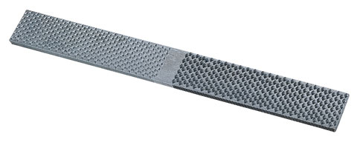](http://hoofcaresupplies.co.uk/wp-content/uploads/2013/11/1616_1.jpg)

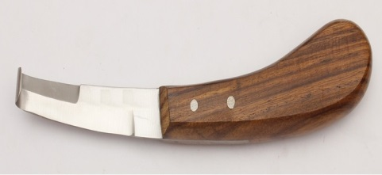

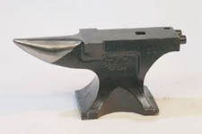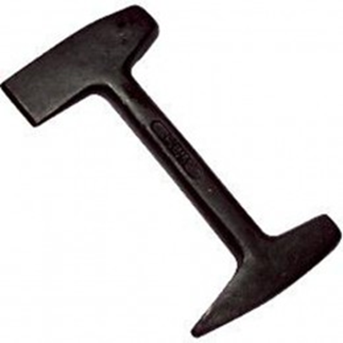

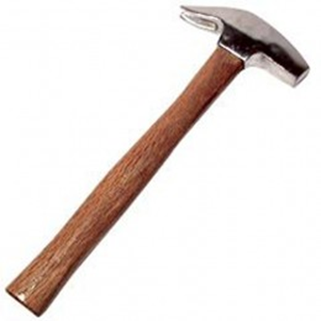

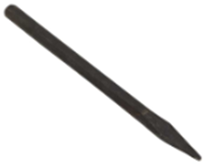

**SHOEING / CARE OF FOOT**

Observation sheet—Ask someone to watch you carry out the following tasks.

|  |  |  |  |
| --- | --- | --- | --- |
| DATE | TASK | COMPETENT | OBSERVER |
|  | Pick out a horse’s foot. |  |  |
|  |  |  |  |
|  | Identify farrier tools. |  |  |
|  |  |  |  |
|  | Demonstrate how to remove a shoe. |  |  |
|  |  |  |  |
|  | Discuss the condition of the horse’s foot. |  |  |

**4. HORSE CARE & STABLE MANAGEMENT**

**PART 6 SADDLERY**

In this part you will cover:

1. care of tack.

2. lungeing equipment.

3. boots, breastplates & martingales.

4. inspection of tack for fit & condition.

5. principles of bitting.

**Aims**

The aim of this part is for you to be able to fit and recognise tack as well as taking adequate care and recognising different types of

saddlery.

**Objectives**

On completion of this part you should be able to:

• recognise all equipment stated.

• fit all equipment.

• understand their uses.

• state the condition & fit of tack.

• understand the principles of bitting.

**SADDLERY**

|  |  |  |
| --- | --- | --- |
| 1. Walk around your tack room making a list of each item of tack and equipment including:    • martingales (*which type?*)  • boots (*which type?*)  • bits etc. | | |
|  |  |  |
|  |  |  |
|  |  |  |
|  |  |  |
|  |  |  |
|  |  |  |
|  |  |  |
|  |  |  |
|  |  |  |
|  |  |  |
|  |  |  |
|  |  |  |
|  |  |  |
|  |  |  |
|  |  |  |
|  |  |  |
|  |  |  |

**BRIDLES**

|  |  |  |
| --- | --- | --- |
| 1. List the parts of a bridle. | | |
|  |  |  |
|  |  |  |
|  |  |  |
|  |  |  |
| 2. State how you would fit a bridle. Show how to put on a bridle with a cavesson nose band. | | |
| 3. Name four different nose bands and state their uses. | | |
|  |  |  |
|  |  |  |
|  |  |  |
|  |  |  |
|  |  |  |
| 4. State the consequences of an ill-fitting bridle. | | |
|  |  |  |
|  |  |  |
|  |  |  |
|  |  |  |
|  |  |  |
|  |  |  |

**BITS**

|  |  |  |
| --- | --- | --- |
| 1. List the seven areas which are affected by the bit. | | |
|  |  |  |
|  |  |  |
|  |  |  |
|  |  |  |
|  |  |  |
|  |  |  |
|  |  |  |
| 2. What factors may affect bitting? | | |
|  |  |  |
|  |  |  |
|  |  |  |
|  |  |  |
|  |  |  |
|  |  |  |
|  |  |  |
|  |  |  |
|  |  |  |

|  |
| --- |
| 3. List the ways in which a horse may resist the bit. |
|  |
|  |
|  |
|  |
|  |
|  |
| 4. State the consequences of an ill-fitting bit. |
|  |
|  |
|  |
|  |
|  |
|  |
|  |
|  |
|  |
|  |

6. Identify the following bits:





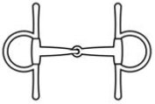



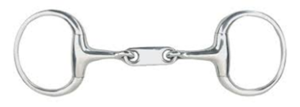

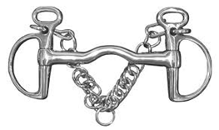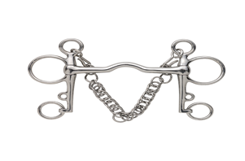

**SADDLES**

|  |
| --- |
| 1. List four different types of saddles and state their uses. |
|  |
|  |
|  |
|  |
|  |
|  |
| 2. Using the back of this sheet either draw or stick a picture of a saddle then point out all parts of the saddle. |
| 3. List what you are looking for when buying a second-hand saddle, i.e. condition etc. |
|  |
|  |
|  |
|  |
|  |
| 4. List key points when fitting a saddle. |
|  |
|  |
|  |
|  |

|  |
| --- |
| 5. State how to fit a saddle (*use an extra sheet*). |
| 6. State the consequences of an ill-fitting saddle. |
|  |
|  |
|  |
|  |
|  |
|  |
|  |
|  |
|  |
|  |
|  |
| 7. List four different types of girths and state their uses. |
|  |
|  |
|  |
|  |
|  |
|  |
|  |
|  |
|  |

**CARE OF TACK**

|  |
| --- |
| 1. Write up a step-by-step account of how to clean tack and state why it is important. |
|  |
|  |
|  |
|  |
|  |
|  |
|  |
|  |
|  |
|  |
|  |
|  |
|  |
|  |
|  |
|  |
|  |
|  |

|  |
| --- |
| 2. List equipment needed to clean tack. |
|  |
|  |
|  |
|  |
|  |
|  |
|  |
| 3. How should tack be stored? |
|  |
|  |
|  |
|  |
|  |
|  |
|  |
|  |
|  |

|  |
| --- |
| 1. List equipment needed for lunging. |
|  |
|  |
|  |
| 2. State how to fit lunging equipment ( use a separate sheet ) |
| 3. List different types of boots and state their uses. (*Use a separate sheet if necessary).* |
|  |
|  |
|  |
| 4. Show how to fit exercise and travel boots (*observation sheet*). |
| 5. List four different types of girths and state their uses. |
|  |
|  |
|  |
| 6. List different types of breastplates and martingales and state their uses. |
|  |
|  |
|  |
|  |

**LUNGING EQUIPMENT**

**SADDLERY**

|  |  |  |  |
| --- | --- | --- | --- |
| DATE | TASK | COMPETENT | OBSERVER |
|  | Identify parts of the saddle: |  |  |
|  | pommel |  |  |
|  | cantle |  |  |
|  | waist |  |  |
|  | seat |  |  |
|  | saddle flaps |  |  |
|  | skirt |  |  |
|  | stirrup bar |  |  |
|  | stirrup leather |  |  |
|  | stirrup iron |  |  |
|  | gullet |  |  |
|  | panel |  |  |
|  | buckle guard |  |  |
|  | Identify parts of the bridle: |  |  |
|  | head piece |  |  |
|  | browband |  |  |
|  | throat lash |  |  |
|  | cheek pieces |  |  |
|  | bit |  |  |
|  | noseband |  |  |
|  | reins |  |  |

**SADDLERY**

|  |  |  |  |
| --- | --- | --- | --- |
| DATE | TASK | COMPETENT | OBSERVER |
|  | How to saddle a horse: |  |  |
|  | saddle is placed forward on the withers. |  |  |
|  | saddle is then slid back into place. |  |  |
|  | girth is lowered from the opposite side, being careful not to startle the horse with the girth. |  |  |
|  | girth is fastened loosely on the left-hand side of the horse. |  |  |
|  | girth is checked and tightened. |  |  |
|  | Show how to fit a bridle with a caveson noseband: |  |  |
|  | reins taken over head. |  |  |
|  | bit is held up to the horse’s mouth and slipped inside. |  |  |
|  | headpiece is lifted over the horse’s ears as the bit goes into the horse’s mouth. |  |  |
|  | throatlash & noseband are fastened. |  |  |
|  | other parts adjusted as necessary. |  |  |

**SADDLERY**

Observation sheet—Ask someone to watch you carry out the following tasks.

|  |  |  |  |
| --- | --- | --- | --- |
| DATE | TASK | COMPETENT | OBSERVER |
|  | Show how to fit travel or  exercise boots: |  |  |
|  | boots identified. |  |  |
|  | boots put on (due care & attention to safety). |  |  |
|  | boots removed, lower strap unfastened first. |  |  |
|  | removed and cleaned. |  |  |

**4. HORSE CARE & STABLE MANAGEMENT**

**PART 7 GROOMING**

In this part you will cover:

1. identifying grooming equipment.

2. strapping a horse.

3. quartering a horse.

4. reasons for grooming.

5. care after exercise.

**Aims**

The aim of this section is for you to learn how to groom a horse.

**Objectives**

The objective of this part is for you to be able to:

• identify all grooming equipment & know their uses.

• state what quartering & strapping are.

• demonstrate quartering & strapping.

• know the reason for grooming.

• know how to care for a horse after exercise.

**GROOMING**

|  |
| --- |
| 1. Identify each part of the grooming kit and state the uses of each item (*observation sheet*). |
| 2. List reasons for grooming. |
|  |
|  |
|  |
| 3. State how you would quarter a horse and why. |
|  |
|  |
|  |
|  |
| 4. State how you would strap a horse and why. |
|  |
|  |
|  |
|  |
|  |
|  |

|  |
| --- |
| 5. Write a short description on how you would care for a horse after exercise. |
|  |
|  |
|  |
| 6. State what considerations you would take into account when grooming a sick horse. |
|  |
|  |
|  |
| 7. What amount of grooming would you give a grass-kept horse and why? |
|  |
|  |
|  |
|  |
|  |
| 8. How would you groom a stable-kept horse? |
|  |
|  |
|  |
|  |
|  |

**GROOMING**

Observation sheet—Ask someone to watch you carry out the following tasks.

|  |  |  |  |
| --- | --- | --- | --- |
| DATE | TASK | COMPETENT | OBSERVER |
|  | Recognise grooming equipment: |  |  |
|  | body brush |  |  |
|  | dandy brush |  |  |
|  | water brush |  |  |
|  | rubber curry-comb |  |  |
|  | plastic curry-comb |  |  |
|  | metal curry-comb |  |  |
|  | mane comb |  |  |
|  | hoof pick |  |  |
|  | wisp |  |  |
|  | stable rubber |  |  |
|  |  |  |  |
|  | State the use of all the above. |  |  |

Demonstrate how to strap a horse.

(*observer comments*)

Demonstrate how to quarter a horse.

(*observer comments*)

**4. HORSE CARE & STABLE MANAGEMENT**

**PART 8 FITTENING / ROUGHING OFF**

You will cover:

1. fittening.

2. exercise program.

3. preparation before fittening.

4. how the time of year may affect fittening.

5. working on metalled roads or heavy-going surfaces.

6. roughing off.

7. preparation for roughing off.

8. feeding: feed charts & how to increase / decrease feed.

**Aims**

Your aims are to understand the whole process of getting a horse up from grass, fittening & roughing off.

**Objectives**

On completion of this part you should be able to:

• know how to work out a fittening program.

• know how to make up a feed chart.

• know what preparations need to be made to the horse whilst still out at grass.

• understand the problems which you may incur whilst

working your horse on metalled roads or heavy-going

surfaces.

• know how to rough a horse off.

**FITTENING**

This is the process when a horse is brought up from grass after

having time off and made fit again. Muscles, ligaments and tendons need to be stretched and made supple. How much work the horse will need will depend on how fit he needs to be.

|  |
| --- |
| 1. What condition is a horse likely to be in, having been out at grass for several weeks with no exercise? |
|  |
|  |
|  |
| 2.  On your yard you are asked to get a 15 hands horse up to medium work (walk, trot, canter, some jumping, a couple of hours hunting).    a) What preparations would you need to make before you bring him up from the field? |
|  |
|  |
|  |
| b) How would you begin to get him fit? |
|  |
|  |
|  |

|  |
| --- |
| c) How long will it take before he is up to medium work? |
|  |
|  |
|  |
| d) Draw up an exercise program in the form of a chart. |
|  |
|  |
|  |
|  |
|  |
|  |
|  |
|  |
|  |
|  |
|  |
|  |
|  |
| e) What factors would affect the length of time it would take to get him fit? |
|  |
|  |
|  |
|  |

|  |
| --- |
| f) List the dangers of working a horse on metalled roads or on deep or heavy-going surfaces. |
|  |
|  |
|  |
|  |
|  |
|  |
| g) What care would you need to take after working your horse? |
|  |
|  |
|  |
|  |
|  |
| h) If the horse is not being worked that day, what form of exercise will you give it? |
|  |
|  |
|  |
|  |
|  |
|  |

**ROUGHING OFF**

|  |
| --- |
| 1. List how you would prepare a fit horse to be roughed off and turned out to grass. |
|  |
|  |
|  |
|  |
|  |
|  |
|  |
|  |
|  |
| 2. How long should the roughing off process take? |
|  |
|  |
|  |
| 3. What external factors may slow the process down? |
|  |
|  |
|  |
|  |

**FEEDING**

|  |
| --- |
| 1. Work out a feeding program in relation to work being done over the fittening process. State what you will do to the feeding program when you prepare to rough your horse off. |
|  |
|  |
|  |
|  |
|  |
|  |
|  |
|  |
|  |
|  |
|  |
|  |
|  |
|  |
|  |
|  |
|  |

**4. HORSE CARE & STABLE MANAGEMENT**

**PART 9 LUNGING**

This part will include:

1. lunging equipment.

2. tacking up for lunging.

3. lunging procedure.

4. practical lunging.

**Aims**

Your aims are to become proficient at lunging and understand the reasons for lunging.

**Objectives**

Your objectives are to:

• be able to recognise and fit lunging equipment.

• lunge a horse for exercise.

• know the reasons for lunging.

**LUNGING**

|  |
| --- |
| 1. List four reasons for lunging. |
|  |
|  |
|  |
|  |
| 2. Ask your assessor to observe you tacking up for luging (*observation sheet*). |
| 3. What is the purpose of the lunge cavesson? |
|  |
|  |
|  |
|  |
| 4. List the equipment the lunger requires for safe lunging. |
|  |
|  |
|  |
|  |
| 5. What is the purpose of side reins? |
|  |
|  |

|  |
| --- |
| 6. What is a suitable area for lunging? |
|  |
|  |
|  |
| 7. What is important about the words and tone of voice you would use when lunging? |
|  |
|  |
|  |
| 8. How do you use a lunge-whip? |
|  |
|  |
|  |
| 9. What is the ideal length of a lunge-line? |
|  |
|  |
| 10. How do you change the rein when lunging? |
|  |
|  |

**LUNGING**

|  |  |  |  |
| --- | --- | --- | --- |
| DATE | TASK | COMPETENT | OBSERVER |
|  | Recognise lunge equipment: |  |  |
|  | cavesson |  |  |
|  | saddle |  |  |
|  | bridle |  |  |
|  | lunge-line |  |  |
|  | lunge-whip |  |  |
|  | side reins |  |  |
|  | boots |  |  |
|  | Tack is fitted correctly & efficiently: |  |  |
|  | cavesson |  |  |
|  | saddle |  |  |
|  | bridle |  |  |
|  | lunge-line |  |  |
|  | side reins |  |  |
|  | boots |  |  |
|  | Lunger is properly dressed with regard to safety: |  |  |
|  | hat |  |  |
|  | gloves |  |  |
|  | boots |  |  |

**4. HORSE CARE & STABLE MANAGEMENT**

**PART 10 Rugs & Bandages**

You will cover:

1. rugs.

2. bandages.

3. storage & care of rugs.

**Aims**

Your aims are to learn about the different types of clothing and their uses.

**Objectives**

Your objectives are to:

• identify the different types of rugs and their uses.

• learn how to fit rugs.

• put on and take off rugs safely.

• know how to care for clothing.

• know how to bandage for warmth and veterinary reasons.

**RUGS**

|  |
| --- |
| 1. List four types of rugs and state their uses. |
|  |
|  |
|  |
| 2. List four reasons for using rugs. |
|  |
|  |
|  |
| 3. Show and explain to two student trainers how to put a rug on and take it off safely (*observation sheet*). |
| 4. How should you store rugs? |
|  |
|  |
|  |
|  |
| 5. How should rugs be cleaned? |
|  |
|  |
|  |
|  |

**BANDAGES**

|  |
| --- |
| 1. Give five reasons for using bandages. |
|  |
|  |
|  |
|  |
|  |
| 2. List eight rules of bandaging. |
|  |
|  |
|  |
|  |
|  |
|  |
| 3. What should go under bandages? |
|  |
|  |
|  |
|  |
|  |

|  |
| --- |
| 4. What should you take into account when bandaging legs? |
|  |
|  |
|  |
|  |
|  |
| 5. How should you care for bandages after use? |
|  |
|  |
|  |
|  |
|  |
|  |

**CLOTHING**

Observation sheet—Ask someone to watch you carry out the following tasks.

|  |  |  |  |
| --- | --- | --- | --- |
| DATE | TASK | COMPENTANT | OBSERVER |
|  | Putting the rug on: |  |  |
|  | Rug folded in half. |  |  |
|  | Approach horse with due care & attention. |  |  |
|  | Rug is placed forwards of horse’s back. |  |  |
|  | Rug is folded back. |  |  |
|  | Front straps are secured. |  |  |
|  | Back straps are secured. |  |  |
|  | Surcingles are secured. |  |  |
|  | Removing the rug: |  |  |
|  | All straps undone & fastened up (not dangling). |  |  |
|  | Rug folded front to back. |  |  |
|  | Rug is lifted off the horses back with due care & attention. |  |  |

**4. HORSE CARE & STABLE MANAGEMENT**

**PART 11 TRAVELLING**

You will cover:

1. preparing a horse for travelling.

2. equipment, i.e. boots, rugs etc.

3. different modes of transport.

4. dealing with difficult loaders.

5. long journeys.

6. accident procedure.

7. law and requirements for towing.

**Aims**

Your aims are to be competent in preparing a horse for travelling.

**Objectives**

The objectives are to:

• know how to prepare a horse for travelling.

• identify and fit equipment & clothing.

• deal efficiently and sympathetically with difficult loaders.

• know what to do in the event of an accident.

• understand the law and the requirements for towing or

driving a horse box.

• know how to prepare a horse for a long journey.

**TRAVELLING**

|  |
| --- |
| 1. What legal requirements are needed to enable you to drive or tow a box or trailer? |
|  |
|  |
|  |
|  |
|  |
|  |
|  |
|  |
| 2. List safety checks needed before travelling. |
|  |
|  |
|  |
|  |
|  |
|  |
|  |
|  |
|  |

3. List all safety clothing and accessories needed for the horse when travelling.

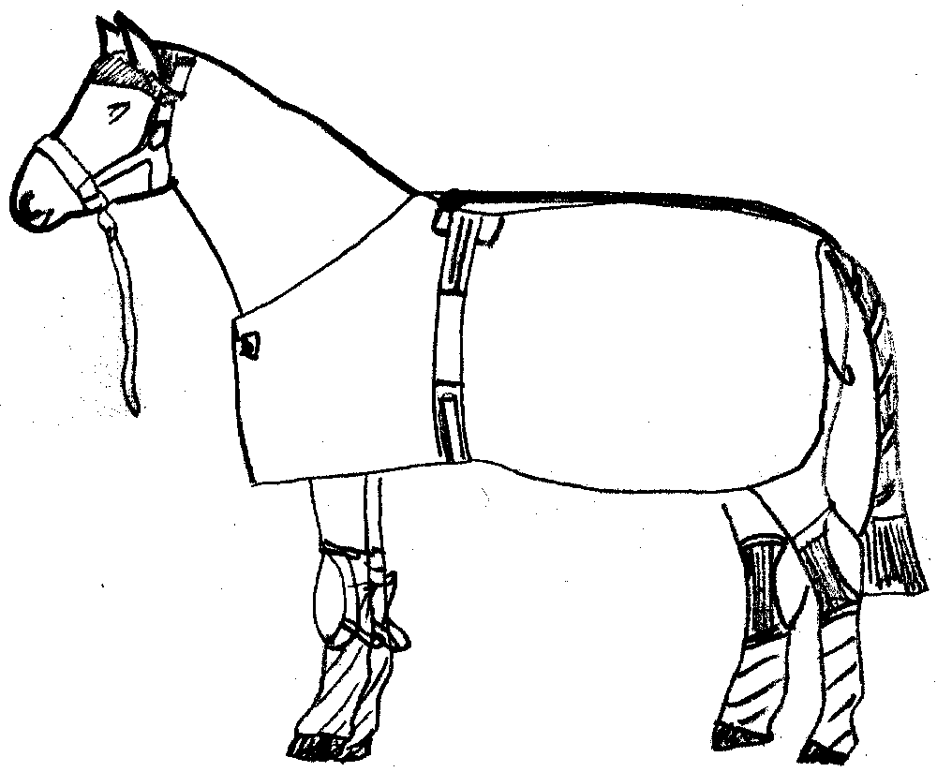

4

5

6

7

8

9

1

2

3

10

|  |
| --- |
|  |
|  |
|  |
|  |
|  |
|  |
|  |
|  |
|  |
|  |

|  |
| --- |
| 4. List what protection the handler should have when loading and unloading a horse. |
|  |
|  |
|  |
|  |
|  |
|  |
|  |
| 5. Long journeys should be planned in advance. List what you need to take into consideration when travelling long journeys with your horse. |
|  |
|  |
|  |
|  |
|  |
|  |
| 6. What is the requirements for passports when travelling? |
|  |
|  |
|  |
| 7. State how you would tie your horse up once loaded. |
|  |
|  |
|  |
|  |
| 8. State the procedure for unloading. |
|  |
|  |
|  |
|  |
| 9. What procedure would you follow in the event of an accident? |
|  |
|  |
|  |
|  |
| 10. What preparation can you do in advance to help a difficult loader to load more easily? |
|  |
|  |
|  |

**TRAVELLING**

Observation sheet—Ask someone to watch you carry out the following tasks.

|  |  |  |  |
| --- | --- | --- | --- |
| DATE | TASK | COMPENTANT | OBSERVER |
|  | Bandage is rolled the correct way. |  |  |
|  | Gamgee placed around the leg |  |  |
|  | Leg is bandaged in an anticlockwise direction on the near side /clockwise on the off side. |  |  |
|  | Same pressure applied all the way around the leg. |  |  |
|  | No wrinkles. |  |  |
|  | Tapes tied on the outside of the leg the same pressure as the bandage. |  |  |
|  | Bandage is removed, cleaned and re-rolled. |  |  |

**4. HORSE CARE & STABLE MANAGEMENT**

**PART 12 CLIPPING & TRIMMING**

You will cover:

1. reasons for clipping.

2. different types of clips.

3. when & how to clip.

4. different clipping machines.

5. dismantling clippers and putting them back together.

6. care of the clippers.

7. safety.

8. trimming.

9. pulling manes & tails.

10. plaiting manes & tails.

**Aims**

Your aims are to know how to clip & trim a horse and to understand the reasons for doing so.

**Objectives**

The objectives are to be able to:

• state the reasons for clipping.

• identify equipment.

• demonstrate how to clip.

• know when to clip.

• know how to care for equipment.

• know what safety precautions are needed.

• know the reasons for trimming.

• know how to pull manes & tails.

• know how to plait a mane or tail.

**CLIPPING & TRIMMING**

|  |
| --- |
| 1. List three reasons for clipping. |
|  |
|  |
|  |
| 2. List six different clips and state when they would be used. |
|  |
|  |
|  |
|  |
| 3. State when and how often you would clip a horse. |
|  |
|  |
|  |
| 4. List safety precautions taken before and during clipping. |
|  |
|  |
|  |
|  |

|  |
| --- |
| 5. What preparations would you make for the horse before  clipping? |
|  |
|  |
|  |
|  |
| 6. What checks would you make to the clippers before using them? |
|  |
|  |
|  |
|  |
| 7. List three different types of clippers. |
|  |
|  |
|  |
| 8. Say briefly how you would care for your clippers during and  after use. |
|  |
|  |
|  |
|  |
|  |

|  |
| --- |
| 9. Why would you trim a horse? |
|  |
|  |
|  |
|  |
|  |
|  |
| 10. When would you trim a horse? |
|  |
|  |
|  |
|  |
|  |
|  |
| 11. State the reasons for plaiting up a horse. |
|  |
|  |
|  |
|  |
|  |
|  |
|  |

**CLIPPING & TRIMMING**

Observation sheet—Ask someone to watch you carry out the following tasks.

|  |  |  |  |
| --- | --- | --- | --- |
| DATE | TASK | COMPENTANT | OBSERVER |
|  | Demonstrate how to trim with scissors & comb. |  |  |
|  |  |  |  |
|  | Demonstrate how to pull a: |  |  |
|  | mane |  |  |
|  | tail |  |  |
|  |  |  |  |
|  | Demonstrate how to plait a: |  |  |
|  | mane |  |  |
|  | tail |  |  |

12. Draw six different clips and name them.

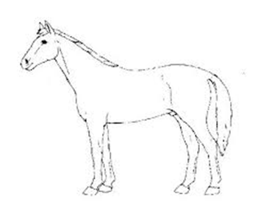







**4. HORSE CARE & STABLE MANAGEMENT**

**PART 13 STABLE DESIGNS**

You will cover:

1. size of stables.

2. building materials.

3. fixtures & fittings.

4. different types of stabling.

5. floors.

6. drainage.

7. doorways.

**Aims**

Your aims are to understand the needs of the horse regarding its

stabling.

**Objectives**

The objectives are to:

• know the sizes of stables to match the sizes of horse.

• understand the durability of materials used in building the stables.

• maintain the stables.

• know what fixtures & fittings are required.

• recognise different types of stabling and their advantages & disadvantages.

**STABLE DESIGNS**

|  |
| --- |
| 1. List four different types of materials used to construct stables. |
|  |
|  |
|  |
| 2. List four different types of flooring. |
|  |
|  |
| 3. How can the floor be constructed to provide adequate drainage? |
|  |
|  |
| 4. List three different materials for roofing. |
|  |
|  |
|  |
| 5. What size should the stable doors be? |
|  |
| 6. Where should the doors be positioned and why? |
|  |
|  |

|  |  |
| --- | --- |
| 7. How should windows open to prevent a draft? | |
|  |  |
|  |  |
| 8. What should cover windows for safety reasons? | |
|  |  |
|  |  |
| 9. Kick-boarding is placed around the inside of the stables between three & four feet high. It is usually made of wood. What is it needed for? | |
|  |  |
|  |  |
| 10. Internal stable lights should be made of either thick durable  plastic or covered by what? | |
|  |  |
| 11. Light switches should be covered to protect them against the weather. Where should they be located? | |
|  |  |
|  |  |
| 12. What size stable would you need for: | |
| a) a horse, 14.2 and under? |  |
| b) a horse, 14.3 and over? |  |
| c) a mare & foal? |  |

|  |
| --- |
| 13. Do you think your stable should have any other fixtures &  fittings? If so, what and why? *(Take into account safety*  *considerations).* |
|  |
|  |
|  |
|  |
|  |
|  |
|  |
|  |
|  |
|  |
|  |
|  |
|  |
|  |
|  |
|  |
|  |
|  |
|  |
|  |

**4. HORSE CARE & STABLE MANAGEMENT**

**PART 14 GRASSLAND MANAGEMENT**

You will cover:

1. good grazing.

2. bad grazing.

3. Boundaries / fencing

4. shelter.

5. water supply.

6. droppings.

7. worm cycle.

8. poisonous plants.

**Aims**

Your aims are to recognise good grazing and poor grazing in order for you to prevent horse sick pasture.

**Objectives**

The objectives are to:

• identify good grazing.

• identify and prevent bad grazing.

• recognise different boundaries / fences and state their advantages & disadvantages.

• recognise the need for shelter and state different kinds.

• state different types of watering systems and their

advantages & disadvantages.

• know the worm cycle.

• identify poisonous plants.

**GRASSLAND MANAGEMENT**

|  |
| --- |
| 1. List six points of good grazing. |
|  |
|  |
|  |
|  |
| 2. List six points of bad grazing. |
|  |
|  |
|  |
|  |
| 3. List four different types of boundary fencing. |
|  |
|  |
|  |
|  |
| 4. List three different types of shelter. |
|  |
|  |
|  |

|  |
| --- |
| 5. List three types of watering systems you may use. |
|  |
|  |
|  |
| 6. What safety precautions are needed if you have a stream or pond in the field? |
|  |
|  |
| 7. List six good grasses. |
|  |
|  |
|  |
|  |
| 8. List six bad grasses. |
|  |
|  |
|  |
|  |
| 9. Droppings are removed from the field in order to keep it looking clean and tidy. List two other reasons for doing this. |
|  |
|  |

|  |
| --- |
| 10. What measures can be taken to reduce the number of worms? |
|  |
|  |
|  |
|  |
| 11. List ten poisonous plants. |
|  |
|  |
|  |
|  |
|  |
|  |
|  |
|  |
| 12. Draw, photograph or find pictures of poisonous plants that you have listed. |
| 13. What are you going to do to maintain a poisonous plant free  paddock? |
|  |
|  |
|  |
|  |