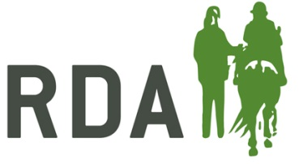
The Extra Mile Award
A coach who has gone that extra mile at Group, Region or National Level over the last 12 months.
NOMINATION FORM
Nominator Details (your details) – Information required for acknowledgements and queries
I am making this nomination - Please circle as appropriate | On behalf of my RDA Group  As an RDA Volunteer  As an RDA Participant  As a parent/carer  As a teacher/TA of a participant  Other description – please state
Nominator’s full name and title

Preferred contact information

Nominee details
Name of Nominee
Name of RDA Group & Coaching Qualification
Approx. age of nominee | Please circle appropriate  16-30  31-55  56 above | Does your nominee know you have submitted this nomination?  Yes / No

Reasons for nomination in a max of 400 words: please give details below, or on a separate sheet, as much information as you can about your nominee’s impact on RDA at Group, County, Region or National level.
Personal characteristics should be included, for example:
- Enthusiasm
- Dedication
- Perseverance
- Innovation
- Selflessness
Please note that nominations are presented to the judges as they are submitted and marks may be lost if the content is unclear.
Name of Nominee
Please outline the reasons for your nomination, including specific examples of the impact they have had on those they have coached and where they have gone above and beyond to help the Group, Region or general organisation:

CLOSING DATE FOR RECEIPT OF NOMINATIONS – 6th September 2019
Return to: RDA, Lowlands Equestrian Centre, Old Warwick Road, Shrewley, Warwickshire, CV35 7AX

For further information or help, please contact Alex Walker on
01926 405971 / awalker@rda.org.uk

