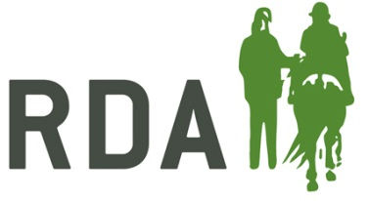
AGREEMENT FORM FOR TRANSFER OF OWNERSHIP OF AN EQUINE FROM AN RDA GROUP

Details: (tick boxes where appropriate):

Passport Name:

Age: | Height:
Colour: | Breed/Type:
ID Details (eg Freeze/Brand, Passport No, Microchip No):

Currently Owned by: .................................................................................RDA GROUP

Address: ............................…...........................................................................................

...................................………………………. Postcode: ………………………..............................

Email: …………………................................ Telephone:…....................................................

Ownership will be transferred to: ...........…................................................................

Address: ............................…...........................................................................................

...................................……………………………………………………………………..............................

Postcode: ............................... Telephone: ..............................................................

Subject to the following conditions:

- Both parties understand that ownership of the named equine above will transfer as of the date stated below. The Passport will be transferred and Passport Issuing Authority informed.
- Overall care of the equine will be the responsibility of the new owner named above and the named RDA group above passes on all responsibility (including financial) of the equine to the new owner as of the date stated below.
- If the ownership of the equine has been passed over due to the equine now being unsuitable to ride/drive, the new owner must agree that the equine will not be ridden/driven and is to only to be used as a companion.
- If for any reason the new owner finds it necessary to change the current arrangements for the equine, their representative will first offer it back to the RDA Group, secondly make every effort to find it another suitable home (keeping in mind statement 5) or thirdly have it humanely euthanised.
- The new owner will have the right and responsibility to see that the equine is euthanised, without delay, should a veterinary surgeon consider it necessary for humane reasons.

Signed: ......................................... (Group Chairman) Date: .................................

Signed: .......................................... (New Owner) Date: .................................

