Welcome On Board
An Introduction to Being a Trustee at RDA
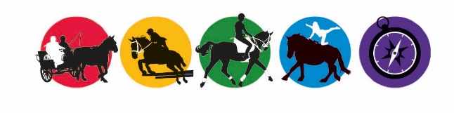
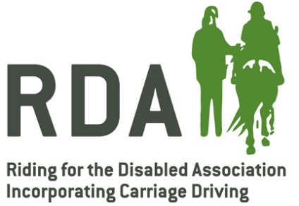
Contents
Welcome and Thank You 3
Role & Responsibilities 4
Being a Trustee 5
Insurance & Protection for Trustees 7
Getting Started 9

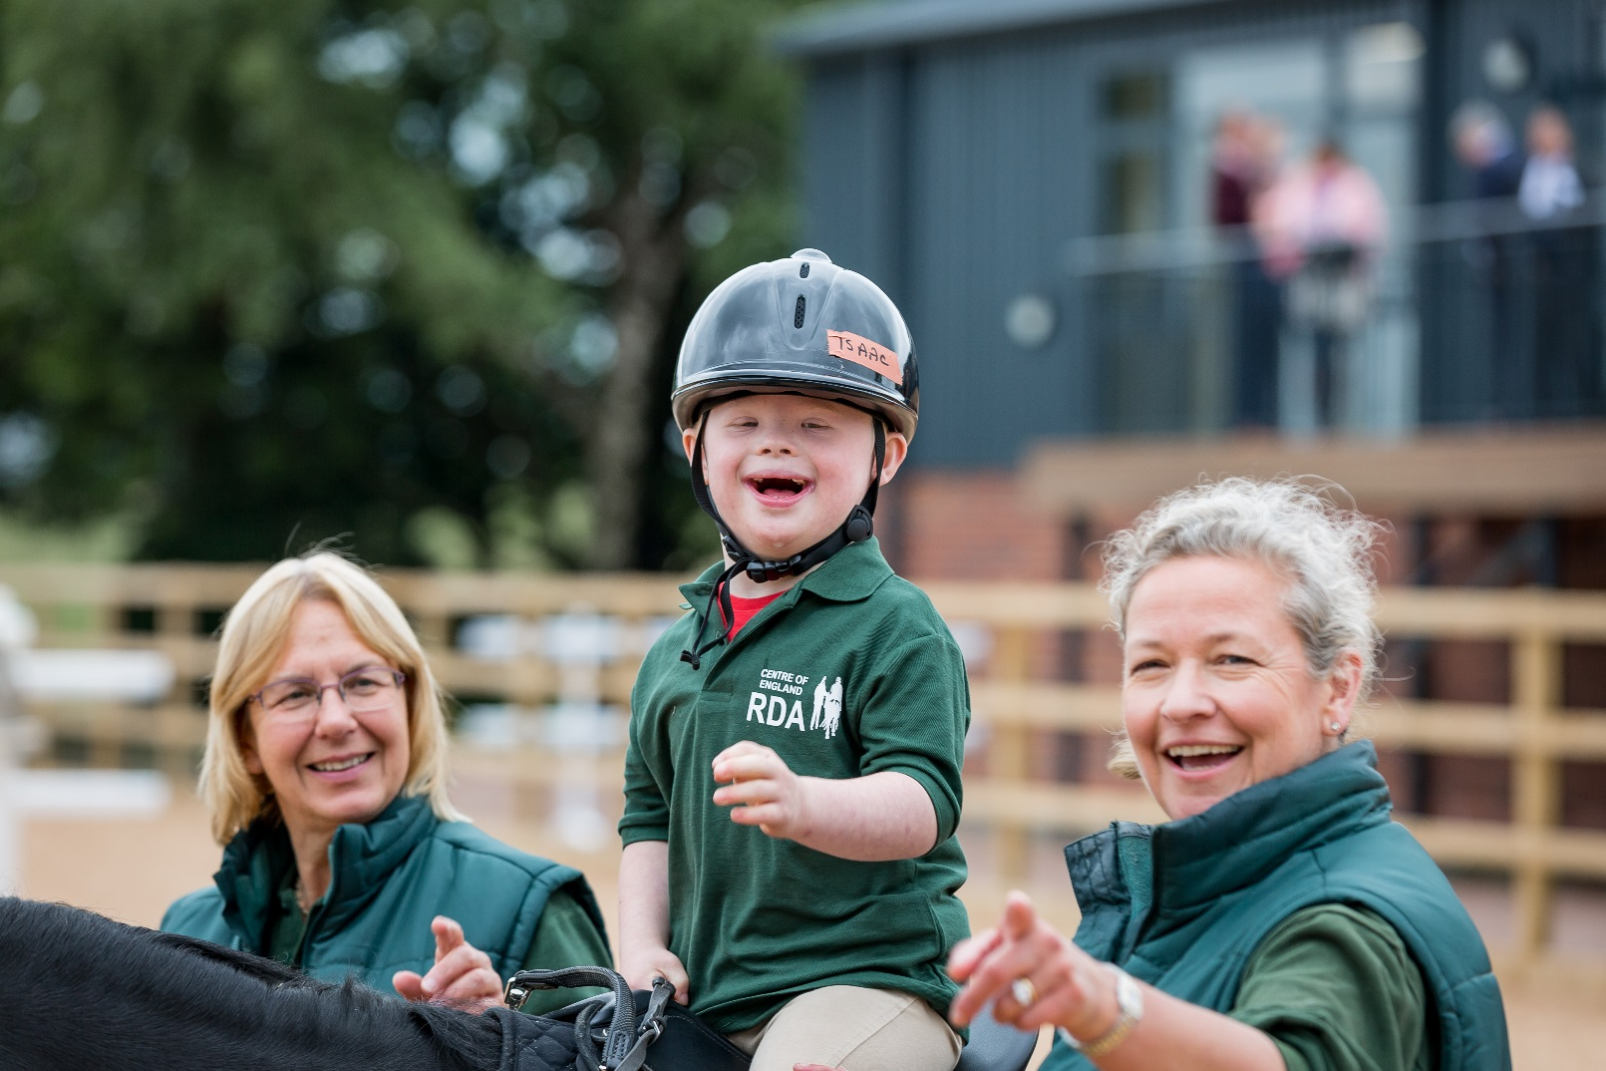

Welcome and Thank You
For over 50 years, Riding for the Disabled Association has been providing opportunities for therapy, achievement and fun to people with disabilities.
Today over 25,600 riders and carriage drivers take part at our groups all over the UK, supported by people like you making up our dedicated team of 18,000 volunteers.
RDA UK is the national support network for the organisation and is comprised of 400 national, regional and county volunteers and 25 staff who provide support and services to RDA’s member groups.

About RDA
- RDA benefits the lives of 25,600 disabled children and adults all over the UK
- Using activities like riding and carriage driving, we provide therapy, fitness, skills development and fun
- RDA has 500 Centres around the UK
- We deliver a measureable impact in life enhancing areas such as physical ability, communication, relationship building and confidence

“We all do it for the challenges; for the rewards of helping people achieve their goals and because we believe in what RDA does.”
Our Values
Our values outline the way in which we work together and the things we believe are important when delivering our services. Our values guide our behaviour and the decisions we make while we are volunteering.
- RDA is a community of people who believe that it’s what you can do that counts and who enable participants and volunteers to achieve their goals
- RDA values the input of all people who are involved – participants, volunteers and paid staff
- RDA ensures that development and achievement is recognised and celebrated across the organisation
- RDA aims to deliver an excellent service and experience for all participants and volunteers
- RDA recognises the central part that horses and ponies play in everything we do

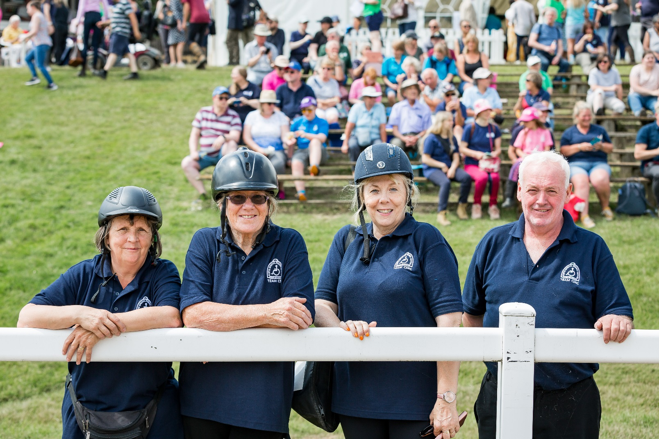

Role & Responsibilities
Trustees play an important role in RDA groups. The role can be divided into three key areas of responsibility.
Protecting the assets of the group
It is the trustees’ role to protect the assets of the charity – in most cases this means money, but it would also apply to other assets such as horses or buildings – and to ensure that they are properly used for the charity’s best interests
Strategy
The trustees decide what the charity should do – it is their role to define the longer-term plans and aspirations of the group
Responsibility to meet legal and operational needs
Trustees must meet the legal and operational needs of the charity – these include issues defined by the government and appropriate governing bodies

Being a Trustee
Becoming a Trustee
Trustees are voted in by the group’s members through a resolution at a Group AGM or EGM
As these meetings occur on an infrequent basis trustees may join the committee prior to this as a cop-opted member after being voted in by the existing trustees. Co-opting is simply a mechanism for bringing someone on to the committee at any time. As a Co-opted member you still have full voting rights.
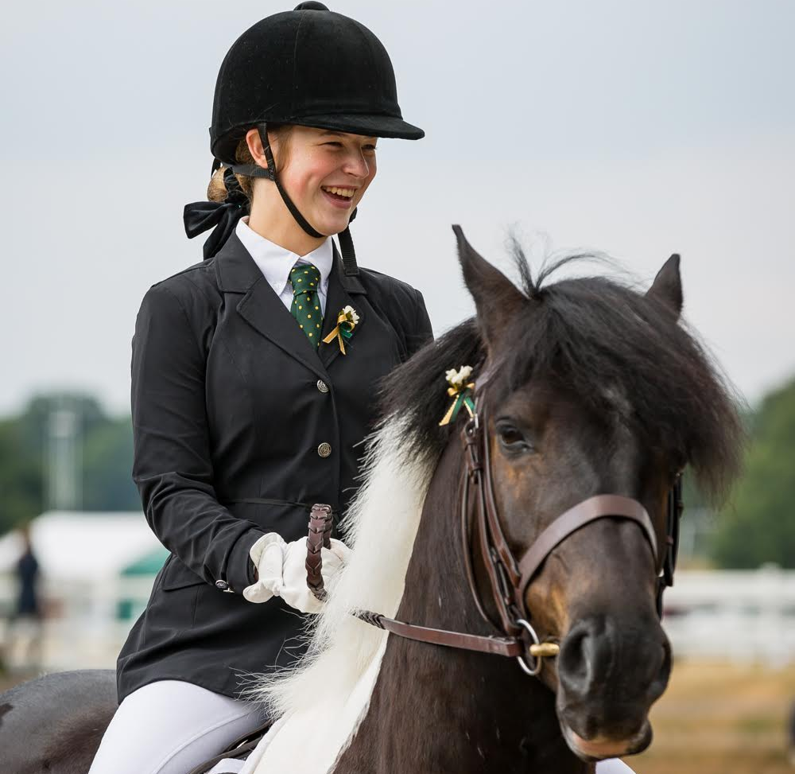
Trustees’ Meetings
Trustees carry out their role through attending and participating in trustee or committee meetings. It is at these meetings that the main strategic decisions for the group are made.
Meetings should be held a minimum of 4 times per year with the addition of the Annual General Meeting. If your group is incorporated you must have a minimum of 1 meeting every six months.

Governing Documents
RDA trustees should be aware of the framework under which they will be required to carry out their responsibilities.
The Mem & Arts (for incorporated groups), the Group Constitution (for unincorporated groups) and the CIO Constitution (for CIOs) set out the framework for the constitutional management of the group including Election of Trustees, Conduct of Meetings, Voting Members and Voting, Powers and Duties.
If you have been approached to become a trustee you should ask the group to see a copy of this document along with the most recent accounts so you have a clear idea of your responsibilities.

“I came to RDA for the horses, but it has taught me so much about people, about respect and about fairness.”
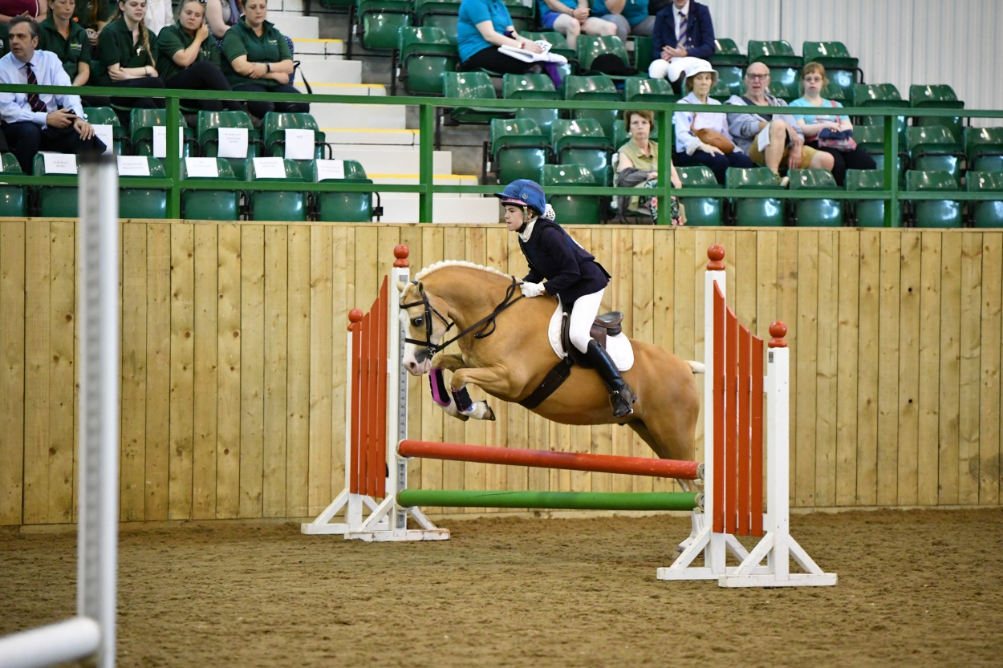

Insurance & Protection for Trustees
Many trustees are concerned about the extent of their liability in the event of a claim of negligence or mal-practice against the group. There is protection in place but like all insurance it does depend on the trustees being able to show that they have acted in good faith and appropriately.
RDA Groups can take different legal forms which offer different levels of protection.
Unincorporated
In an unincorporated group the elected trustees are recognised as legal identities with personal liability for debts and other liabilities.

Incorporated
In an Incorporated Group the group becomes a limited company and so has its own legal personality distinct from its members which means the liability of the trustees is limited.
Incorporation gives the trustees security that insurance alone cannot provide and is essential to ensure the best protection for groups who own property, have a lease or large contract or employ staff.
Charitable Incorporated Organisations (CIOs)
A Charitable Incorporated Organisation is a slightly simpler legal form, which carries the same protection as incorporation but only requires the charity to report to the Charity Commission or OSCR and not Companies House.

RDA Indemnity Insurance
As an elected Trustee, you are covered by the RDA Trustee Indemnity Insurance for up to £7.5 million as well as public liability insurance for £20 million.

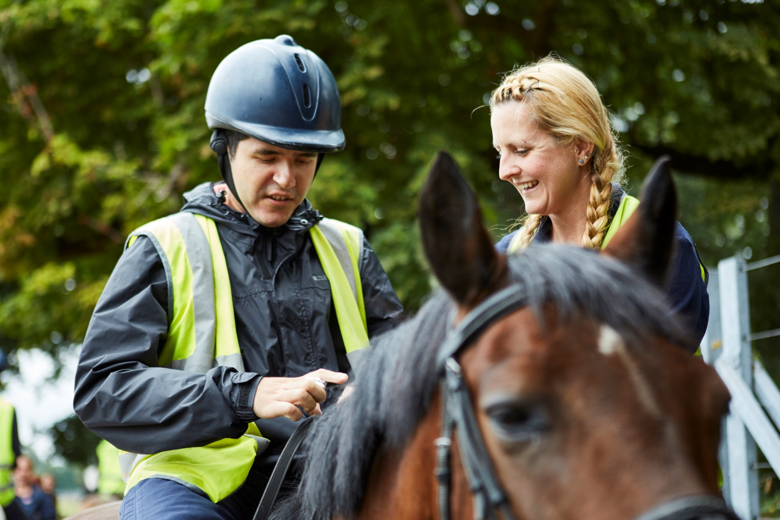

Getting Started
Getting started as an RDA Trustee is a simple process, however there are some key steps to take before you begin volunteering.

Volunteer Application Form
If you are a new volunteer you will need to complete an application form which will include providing two referees. All information provided to the group is confidential and will be used for RDA purposes only.

Trustee Acceptance Form
You will need to sign a trustee acceptance form to demonstrate you understand the role and responsibilities of being an RDA Trustee.

Conflict of Interest Form
As a trustee you have a legal duty to act in the charity’s best interest when making decisions. It may be that a decision needs to be made where you have a personal or other interest which may affect your ability to make a decision in the interest of the charity. This is a conflict of interest.
Having a conflict of interest does not mean you have done anything wrong however it is important to declare this conflict of interest and withdraw from discussions and voting on matters where this applies.
In order to help manage a conflict of interest an important first step is to complete a conflict of interest form upon becoming a trustee.

Disclosure Check
If your role means you are actively involved in delivering an RDA session you will be asked to complete an enhanced disclosure check. The Group Safeguarding Officer will be able to support you with this.

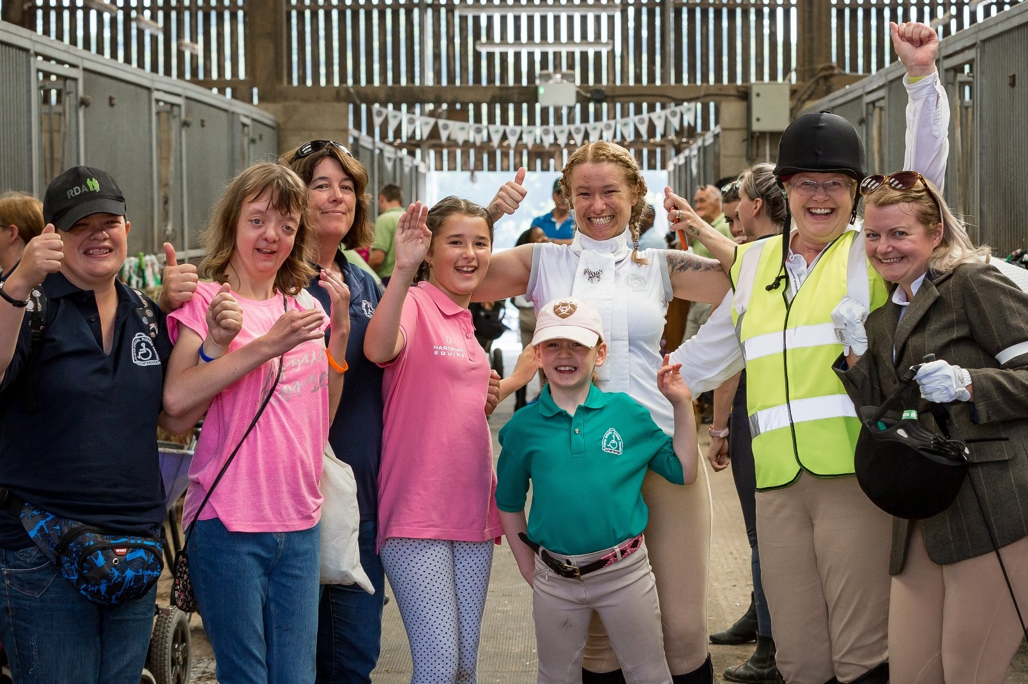

Further Information

National Office Contact
RDA Website
RDA has two websites that provide news, updates and information
www.rda.org.uk promotes RDA to those who are not currently involved and contains our group finder www.myrda.org.uk contains resources and information for RDA volunteers

Contact Faye McKenning,
Volunteer Development Coordinator
Telephone: 01926 405966
Email: fmckenning@rda.org.uk

