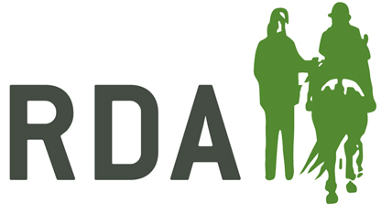
Easing of Restrictions – What it means to RDA Groups

Advice for all parts of the UK
- Social distancing (2M/6FT) remains a key message for everyone not from the same household
- RDA activity has to remain outdoors
- Trustee checklists and Covid-19 Risk Assessment should be completed and emailed to RDA National Office info@rda.org.uk before any RDA activity can begin
Wales from Monday 1st June – Stay Local
People from two different households can meet with no maximum number. Strong advice is not to travel more than five miles, or to stay in the “local area”. There is no restriction on the number of different households you can see in a day, as long as they are separate.
This will allow for the following possible scenarios for RDA in Wales:
- Coach and independent rider session
- Coach and one or more riders from the same household, and others from the rider’s household who can help, including with close contact e.g. mounting and side walking and/or others from the coach’s household who can help whilst maintaining social distancing from the rider(s)
Whilst groups now have no restrictions on how many from two households can attend sessions, please make sure only those who are needed for the session attend to reduce the risk of contamination.
England (from Monday 1 June) & Northern Ireland
Groups of up to six people from different households will be able to meet. This will allow for the following possible scenarios for RDA in England & Northern Ireland:
- Coach and independent rider sessions, as per our previous advice
- Coach and one rider with up to four helpers made up of:-
- members of the rider’s household who have completed the basic training record sheet and can support with close contact e.g. mounting and side-walking
and / or
- group volunteers who will need to socially distance from anyone who is outside of their household
- Coach and more than one rider with support, up to a maximum of six people in total, with social distancing for anyone outside of a person’s household
Whilst groups can now have up to six people at sessions, please make sure only those who are needed for the session attend to reduce the risk of contamination.
Scotland – from Friday 29 May – Stay at home as much as possible
People from two different households can meet, up to a max of eight people. Strong advice is not to travel more than five miles for ‘leisure’. A coach should not deliver sessions to more than one household at any time or in one day.
This will allow for the following possible scenarios for RDA in Scotland:
- Coach and independent rider session
- Coach and one rider with up to six members from the rider’s household who can help, including with close contact e.g. mounting and side walking
- Coach with several riders from the same household, and helpers from the same household – max group of eight including coach
- Coach with helpers from their own household and one rider who can be kept socially distanced
Whilst groups can now have up to eight people at sessions, please make sure only those who are needed for the session attend to reduce the risk of contamination.

