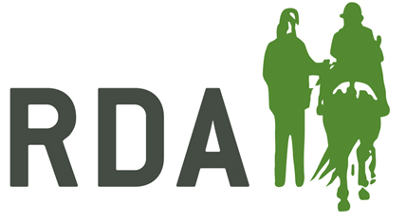
VOLUNTEER REVIEW FORM

Name: Date:
This form is designed to help you reflect on your experiences volunteering with RDA. It is a chance for you to give feedback and also to raise any questions, problems or concerns.

- Volunteering with RDA
How are you finding things generally?
Which aspects of work do you enjoy the most / least?
How is your Relationship with other volunteers?

- Achievements
What have been your recent achievements?
What would you like to do next?

- Strengths
How much are your skills and talents being used at RDA?
Which skills are not being used?
How could this be changed?

- Challenges
What are you finding most challenging?
What do you need to help overcome these challenges?

- Plans For the Future
What will you do next for RDA?
Is there any training you need to develop your role?
Are there any roles you would like to learn more about?

