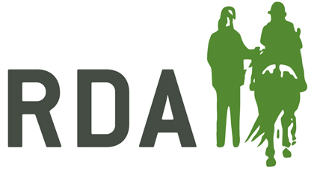
VOLUNTEER REVIEW FORM

Name: Date:
This form is designed to help you reflect on your experiences volunteering with RDA. It is a chance for you to give feedback and also to raise any questions, problems or concerns.

- What have been your recent achievements?

- What are you finding the most challenging?

- Is there any training or support you need?

- Are there any other tasks at RDA you would like to do?

