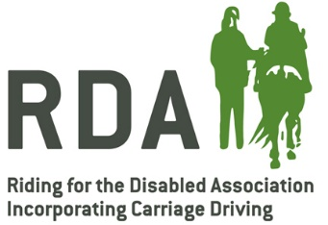
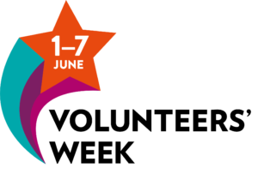

RDA Groups - How to get involved with VW2020
Get some publicity for your group and/or use it as a fundraising opportunity
Download the press release template and adapt it for your local media. You can add in your own stories about your volunteers, and even link it to your fundraising campaign.
Join in on social media
There will be lots of social media activity during the week using #VolunteersWeek #VolunteersWeek2020 and #NeverMoreNeeded. Use the week to highlight the work of your volunteers during lockdown and share with others online.
Charities will be continuing the campaign started in Australia called #WaveForVolunteers. People show their gratitude with a selfie of themselves waving – with a smiley face on their hand! This is a quick and easy way to engage your members with showing their support.
Sign up to pack.org to help spread pre-prepared messages in a co-ordinated manner (these are called ‘howls’) during the week https://my.pack.org/c/vw2020
Share the film
RDA Ambassador Clare Balding has narrated a special short film, which launches on Monday 1 June. It features RDA as well as other participating charities. This will be easy to share on social media so look out for it on RDA UK channels on Monday.
A reason to get in touch
Most groups have been regularly in touch with their members throughout lockdown, but if you’re struggling for inspiration you could use Volunteers Week as an excuse for a virtual get together. Or you could ask everyone to send you their #WaveForVolunteers pictures, put them together in a collage and then send them out to everyone with a big thank you message to your team.
Use the themes to help you
Volunteer recognition will continue throughout the week, with particular focus on different themes each day. Sunday will be a big day for RDA, but we are relevant to most of the themes, so you can adapt your message for each day:
- Monday - Listening & Support
- Tuesday - Health & Well-being
- Wednesday - Fundraising to support service delivery
- Thursday - COVID-19 response and informal community civic action
- Friday - Nature & the Outdoors
- Saturday - Arts & Culture
- Sunday - Sport & Leisure
More about Volunteers Week 2020
- Volunteers Week is a yearly national week taking place 1-7 June. It is a chance to celebrate and say thank you for the contribution millions of volunteers make across the UK.
- Volunteer Scotland, WCVA and Volunteer Now in NI coordinate Volunteers Week in Scotland, Wales and Northern Ireland.
- In England, there is a strong movement of over 80 organisations, led by a group of volunteers, who are getting behind a collaborative effort to champion the importance of Volunteers Week in England.
- We believe in the current time it is even more important to recognise, reach out to and connect together volunteers to share their good news stories.
- It is a strange time for volunteering. There is a mixture of those who feel isolated as they can’t do their usual roles due to the crisis, as well as volunteers who are doing many more hours in frontline roles. There are millions of people who have volunteered to help out, whether informally in their community or as part of organised initiatives, such as the NHS volunteer responders. We also want to thank and remember those volunteers who have lost their lives due to COVID-19.
- Volunteers will also be essential as we come out of the pandemic and people start to re-engage back into their lives, potentially with very different priorities.
- For these reasons, RDA will be coming together with others, to recognise this collective moment in the time. We want to thank and connect volunteers, who are so crucial both now and for our ability to respond as we gradually recover.
- Volunteers Week 2020 will include organisations and individuals joining in thanking volunteers by using the Wave of Appreciation, begun in Volunteers Week Australia in May.
- The #WaveForVolunteers social media campaign will encouraging as many as possible to take a photo of themselves saying thank you to volunteers
- Volunteers Week 2020 connects closely with the #NeverMoreNeeded campaign launched to help the public understand the importance of charities to the national effort to manage the coronavirus pandemic. The #NeverMoreNeeded campaign has been set up to make sure charities’ voices are heard and raise awareness of the work they are doing to help the country come through the crisis and recover. The campaign is phase two of the #EveryDayCounts campaign, which called on the government to provide an emergency financial support package for charities

